Solidworks Shoe Tutorial

Advanced Surface Lofting guide

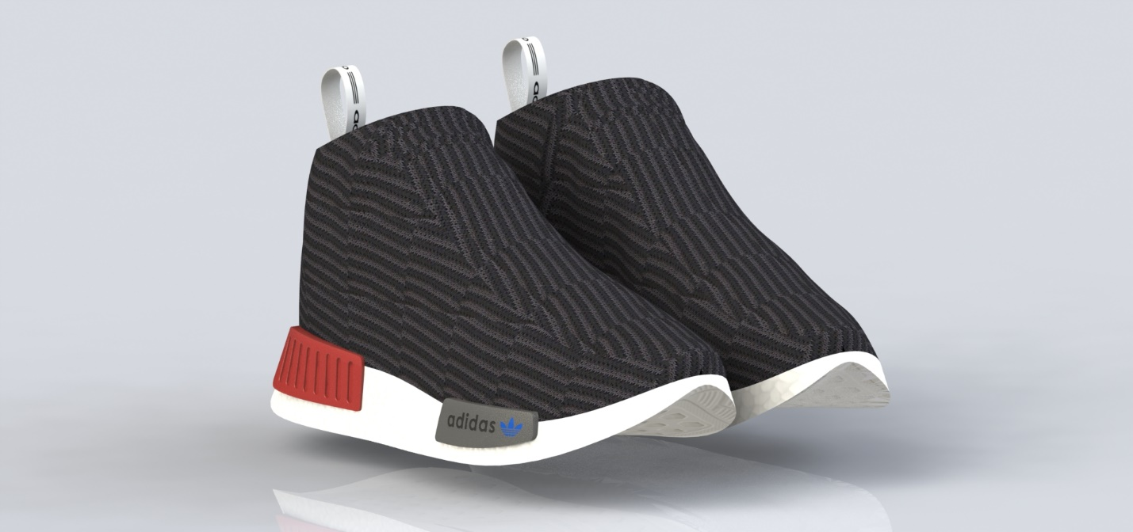

This tutorial will take you step by step the process in creating a shoe in solidworks. As you may know creating organic shapes in solidworks can be tricky. Using lofts and surfaces can give you great results that make abstract and organic shapes.

For this tutorial I have chosen to model the Adidas NMD_CS1 GTX Primeknit Shoes, or the Adidas NMD city sock for short. I chose this shoe because It did not have any laces, and I thought the overall design Is simple enough for an intro to this advanced technique.



This modeling process can be applied to most if not all shoes and many other types of projects that involve an organic shape. As a quick overview to this project we will be making many cross-sections of the shoe with multiple vertical planes running throughout the shoe, then lofting the cross-sections together.

To start this project, you will need as many reference photos of the shoe that you can. For this shoe I found three photos from the Adidas webpage that were all taken of the same shoe and has a side, top, and bottom view of the shoe.

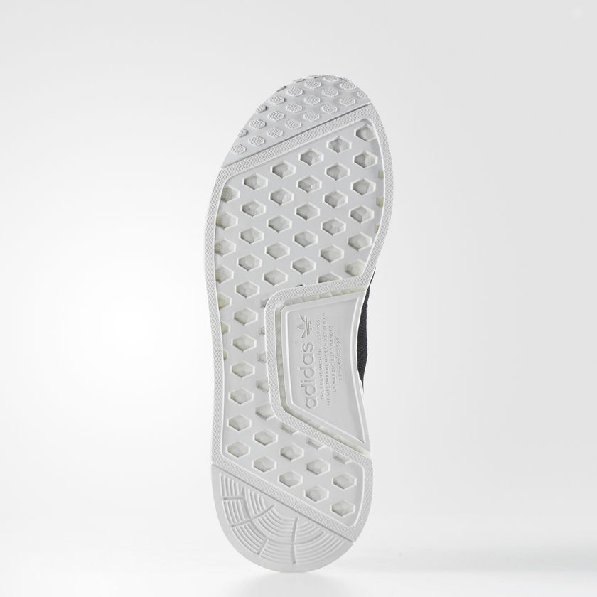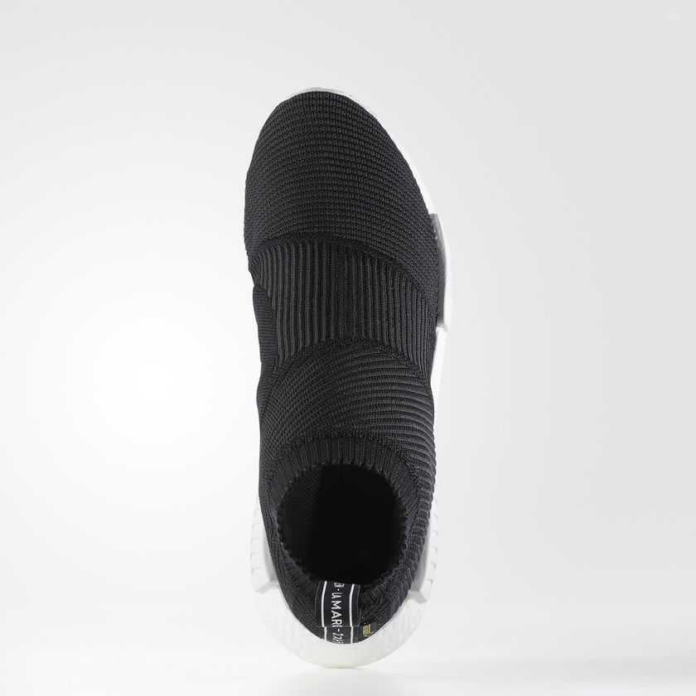

Gathering these pictures are key to this project because we will use little to no dimensions for the design.

After you have your reference photos saved to your computer you need to import them into your part. If you already know how to import a picture, then skip this step.

To create a “sketch picture” short cut, go to your “sketch tab” and right click on the top grey bar, then select customize.

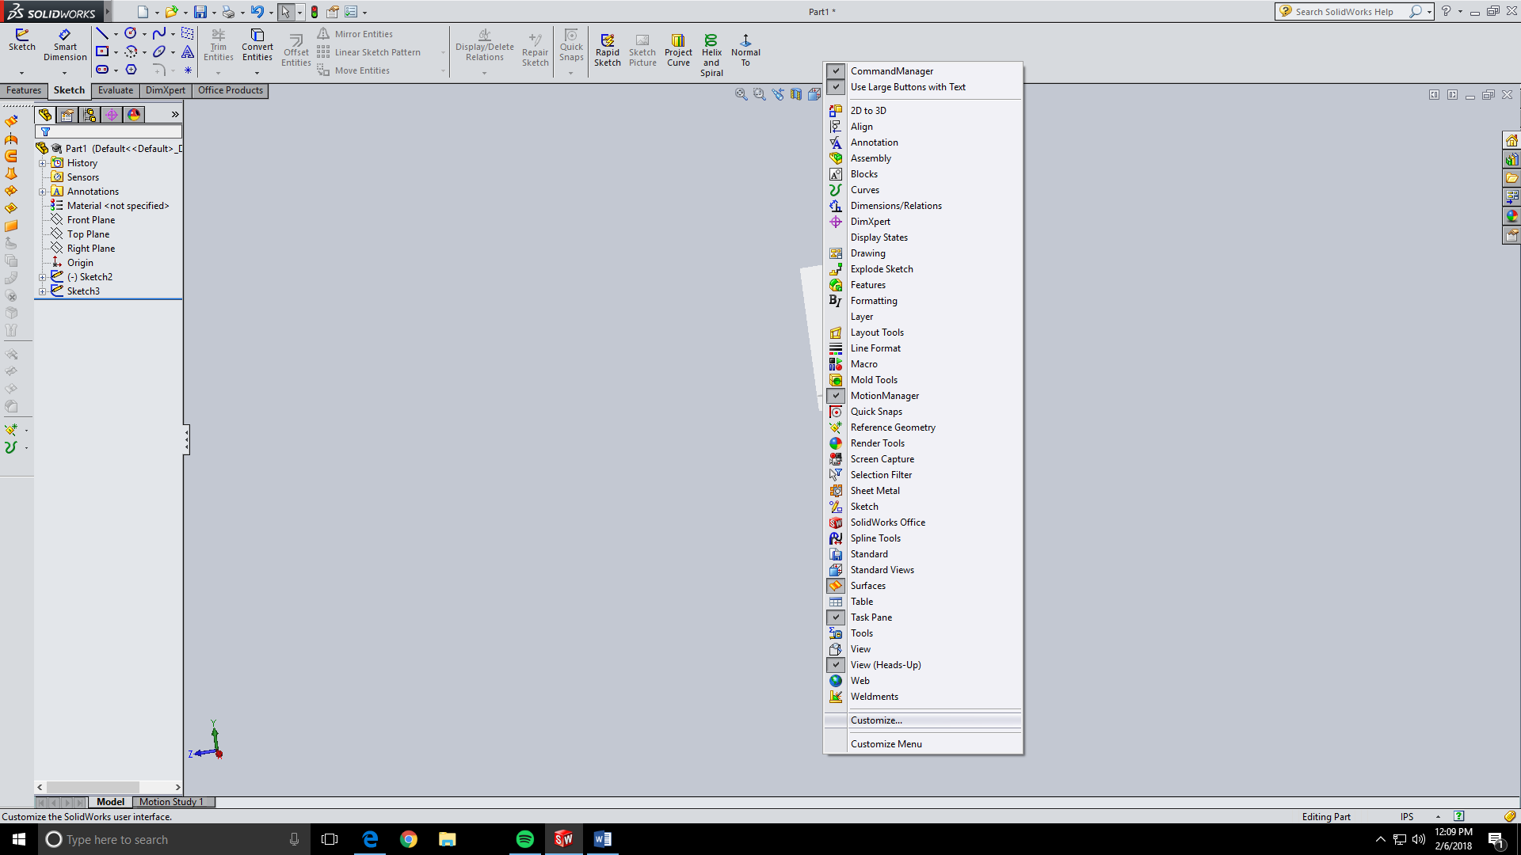

Go to the “Commands” tab and click on the “Sketch” category. Then click and drag on the “sketch picture” Icon and put it on the grey bar you first right clicked on.

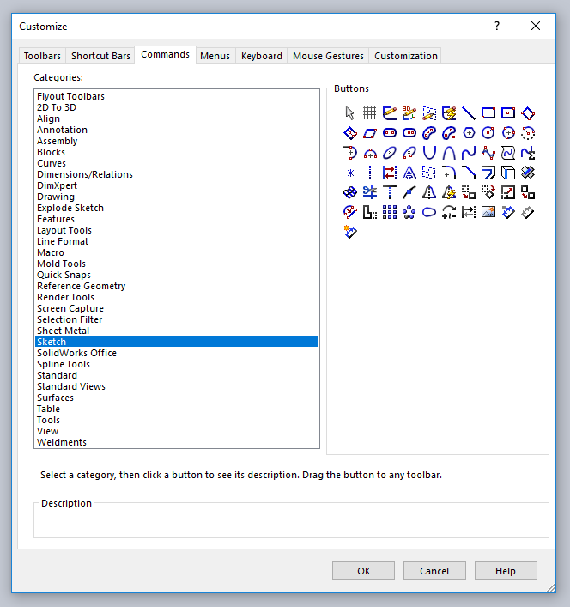

It should look like this when you have finished.

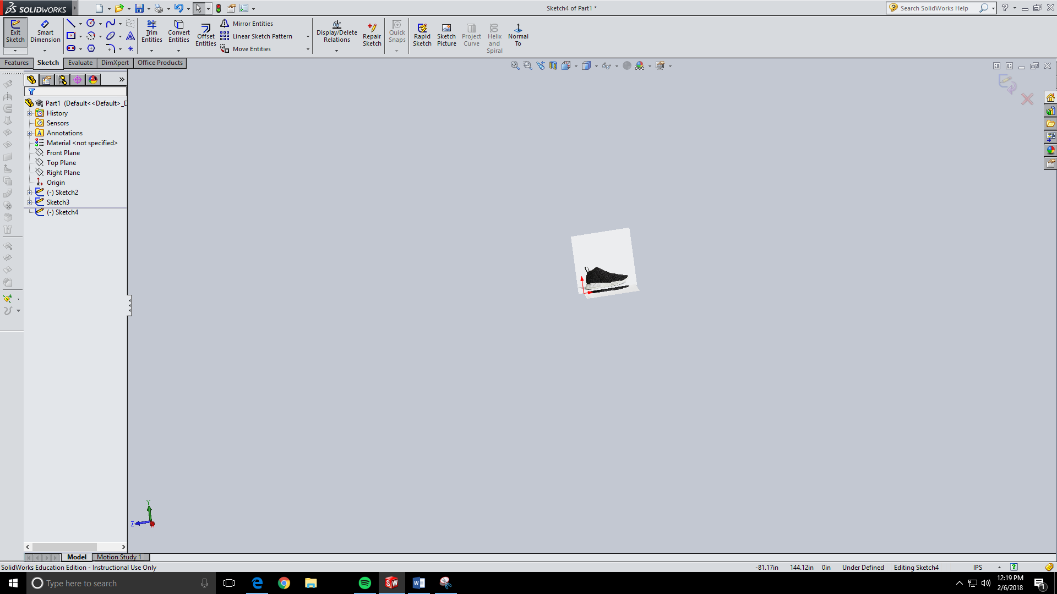

Now that you have your “sketch picture tab you can now go and import your reference photos. Start by importing the picture of the right view of your shoe onto the right plane.

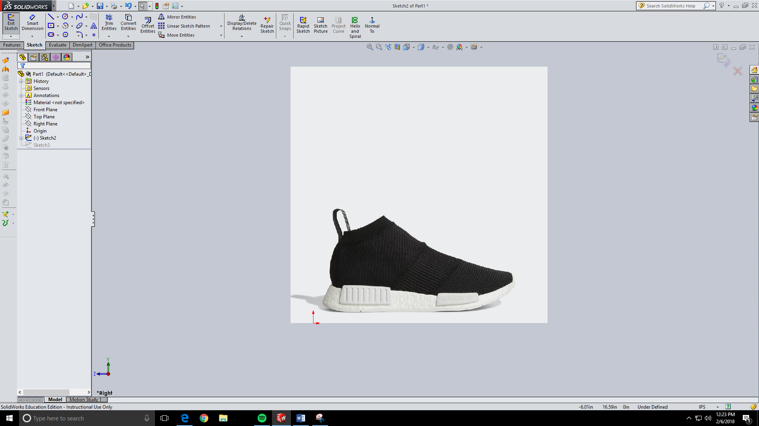

Then on the top plane import a picture of your top view of your shoe. Before you click the check mark you must match up your photos or else you will not be able to do this project!!! What I mean by this is you have to make sure both shoe pictures are the same size and are lined up.

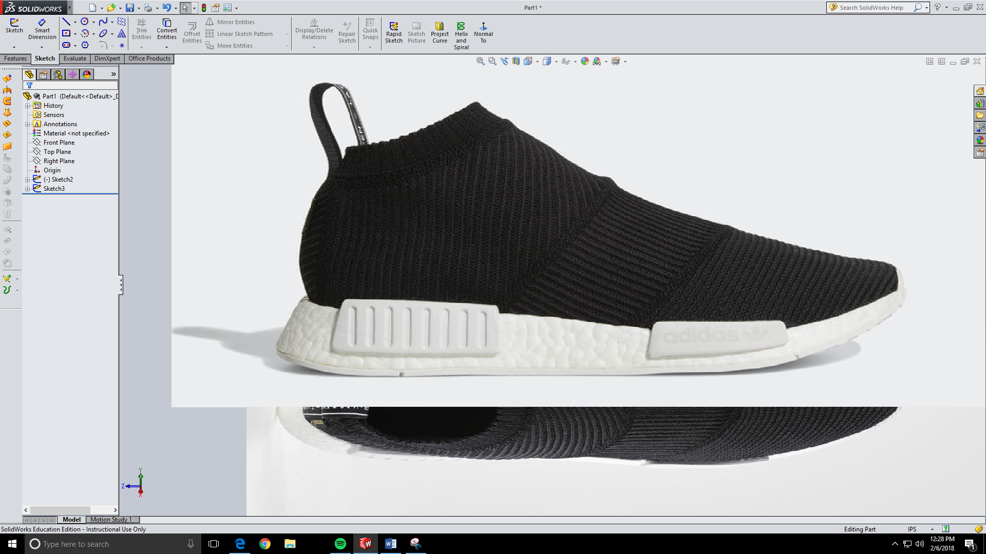

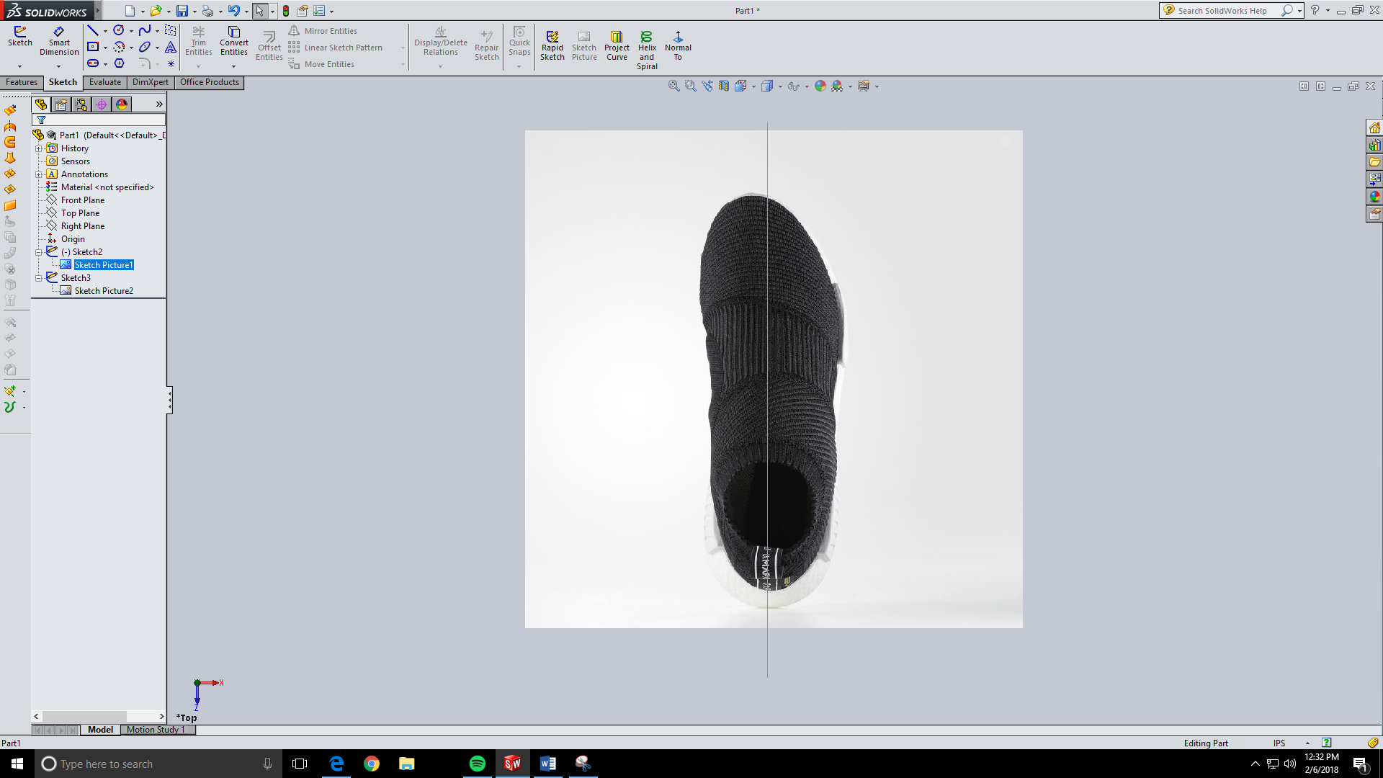

The Blue line is the picture of the side view. See how each picture makes sure the shoes are the same size and lined up so that you can see all angles of the shoe. The next step is to create the sole of the shoe. Go to your top plane and enter A sketch. Then trace the bottom of the sole using the spline tool.

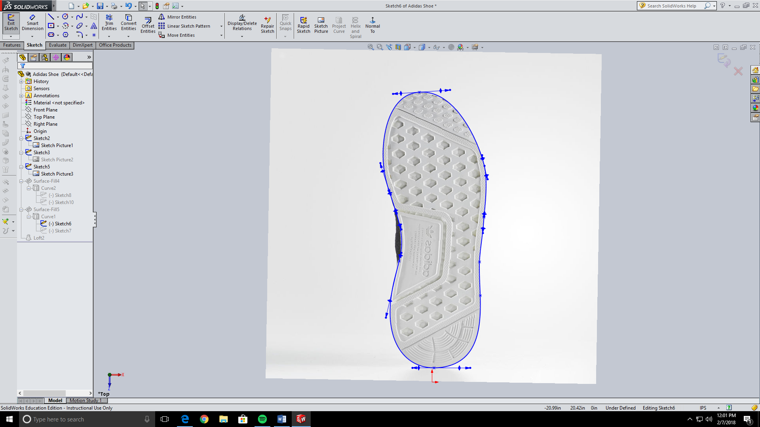

Next make a new sketch on the right plane and trace the outline of the curve of the bottom of the sole. Make sure that the ends of your spline are vertical to the ends of your previous sketch. I used a hidden line to make sure they were in line. If they aren’t in line the project curve we will make will not be closed.

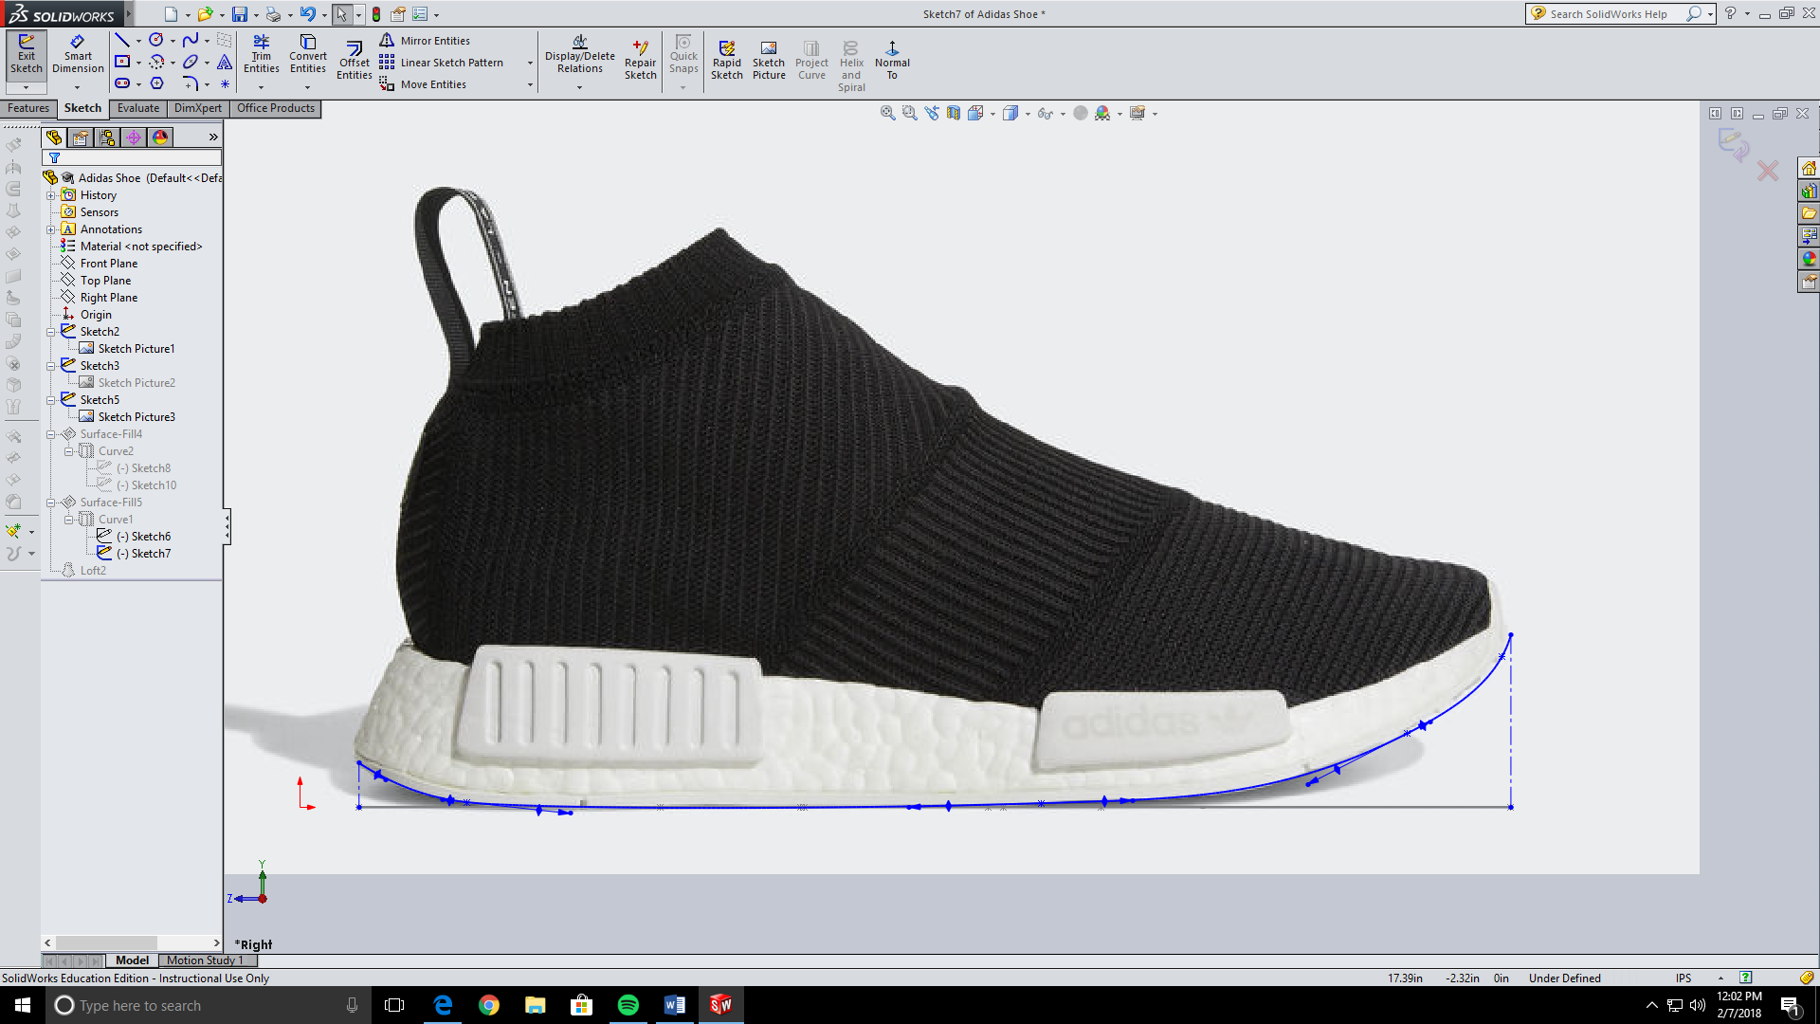

Next make a project curve by selecting it under the curves section in the feature tab. Select the two sketches you just made and it should make a curved version of the first sketch you made.

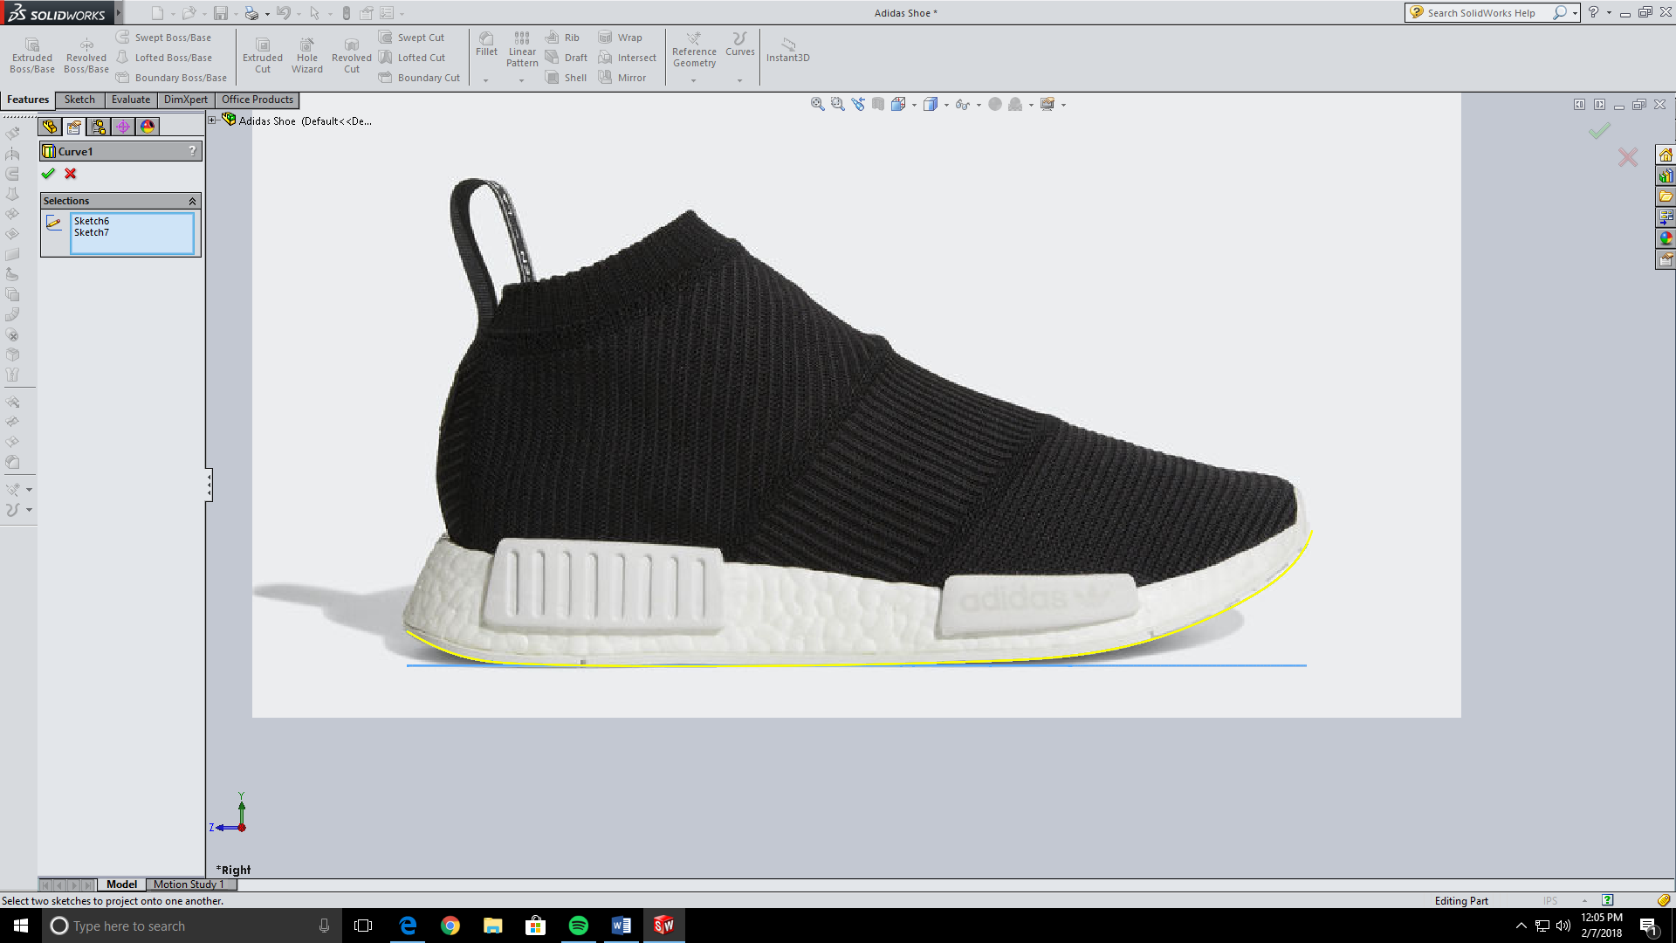

Now we will do the same process but for the top part of the sole. Make a sketch on the top plane again but this time outline the top of the sole not the bottom. You may have to guess a little on this spline if your reference photo blocks your view but just follow the path best you can.

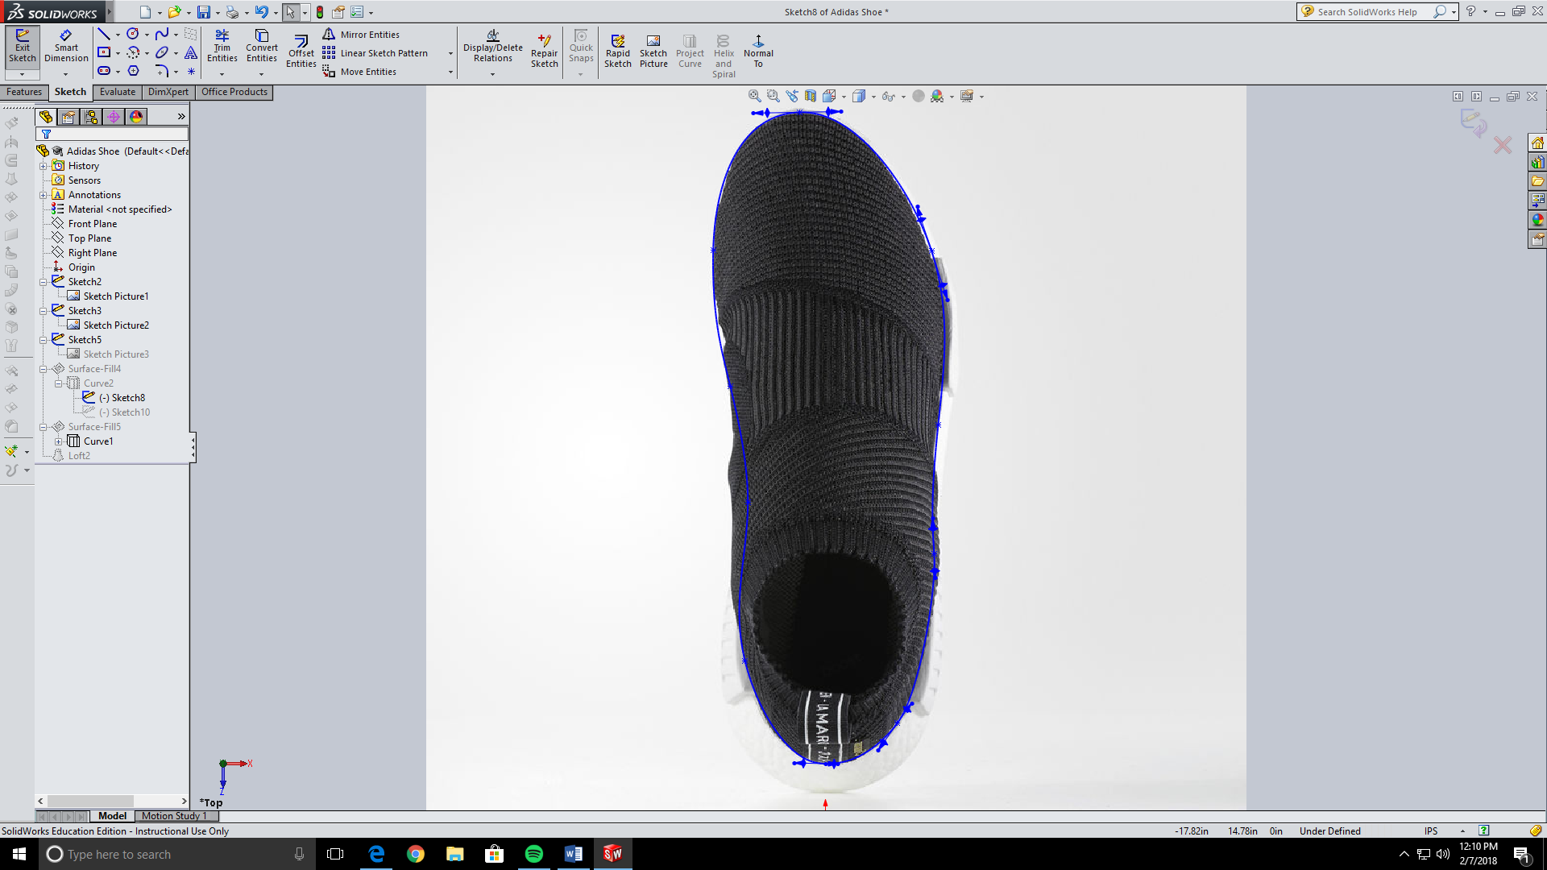

Now make another sketch on the right plane outlining the curve of the top of the sole. Remember to line up the ends of both ends of the sketches.

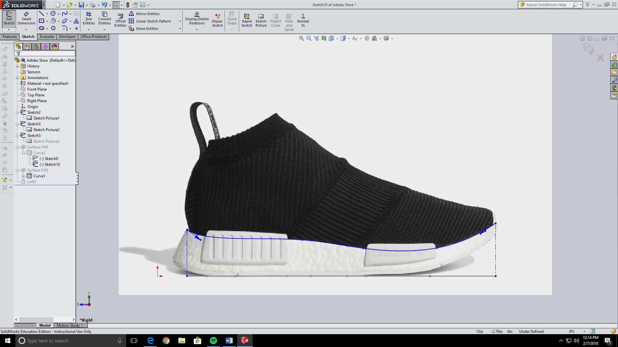

Now make another project curve with the two sketches you just made.

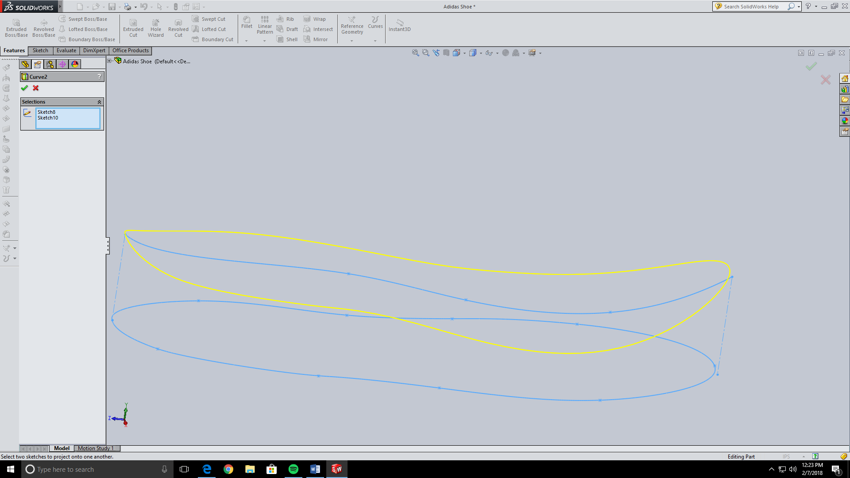

Since solidworks doesn’t allow you to loft two project curves we will make both curves surfaces. To do this you need to make a surface fill. Select your bottom curve and hit the check mark.

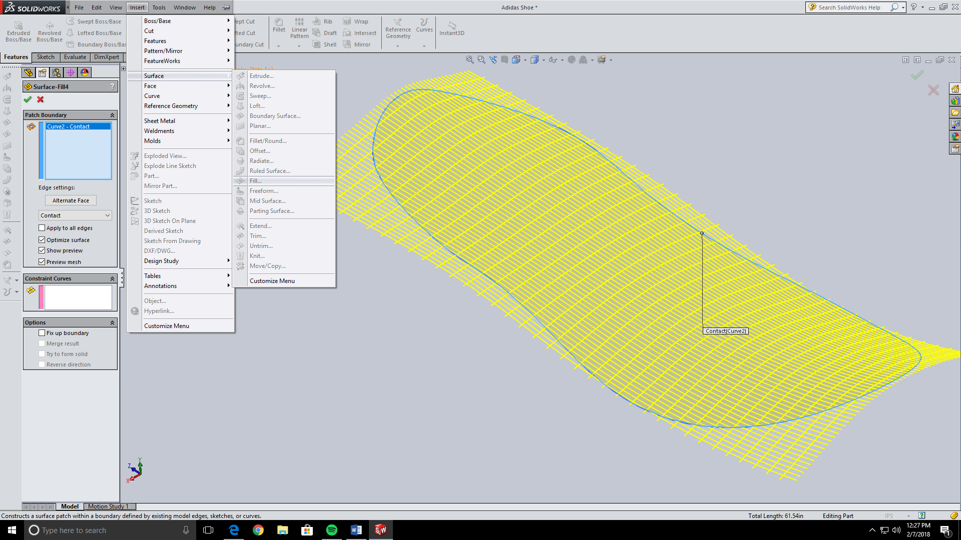



Now do this same thing with the other sketch.

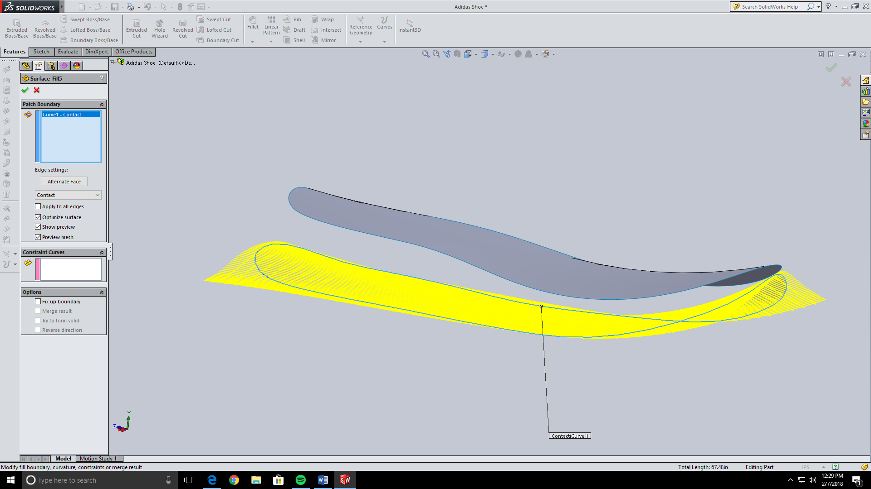

After both project curves are surfaces we can now loft the two together.

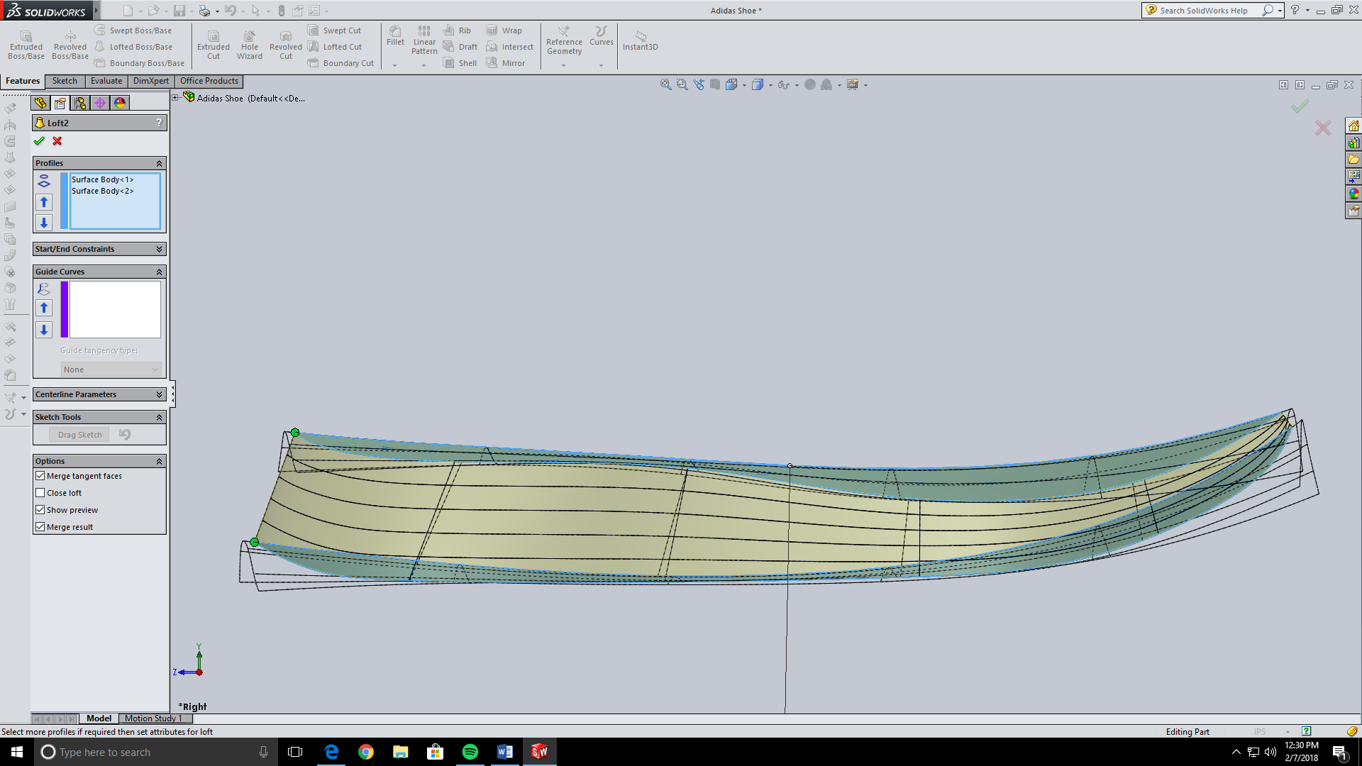

Now our sole is complete. We will move on to the upper of the shoe. We are going to be making a lot of cross-sections of the upper then lofting it all together. We need to have multiple planes running from the tip to the back of the shoe. Make sure to have a plane run through any sharp turn in the shoe. For instance, I made a plane right where the opening where you put your foot in is. Also make a plane at the very tip and very end of the shoe. The more planes the more accurate the finished product.

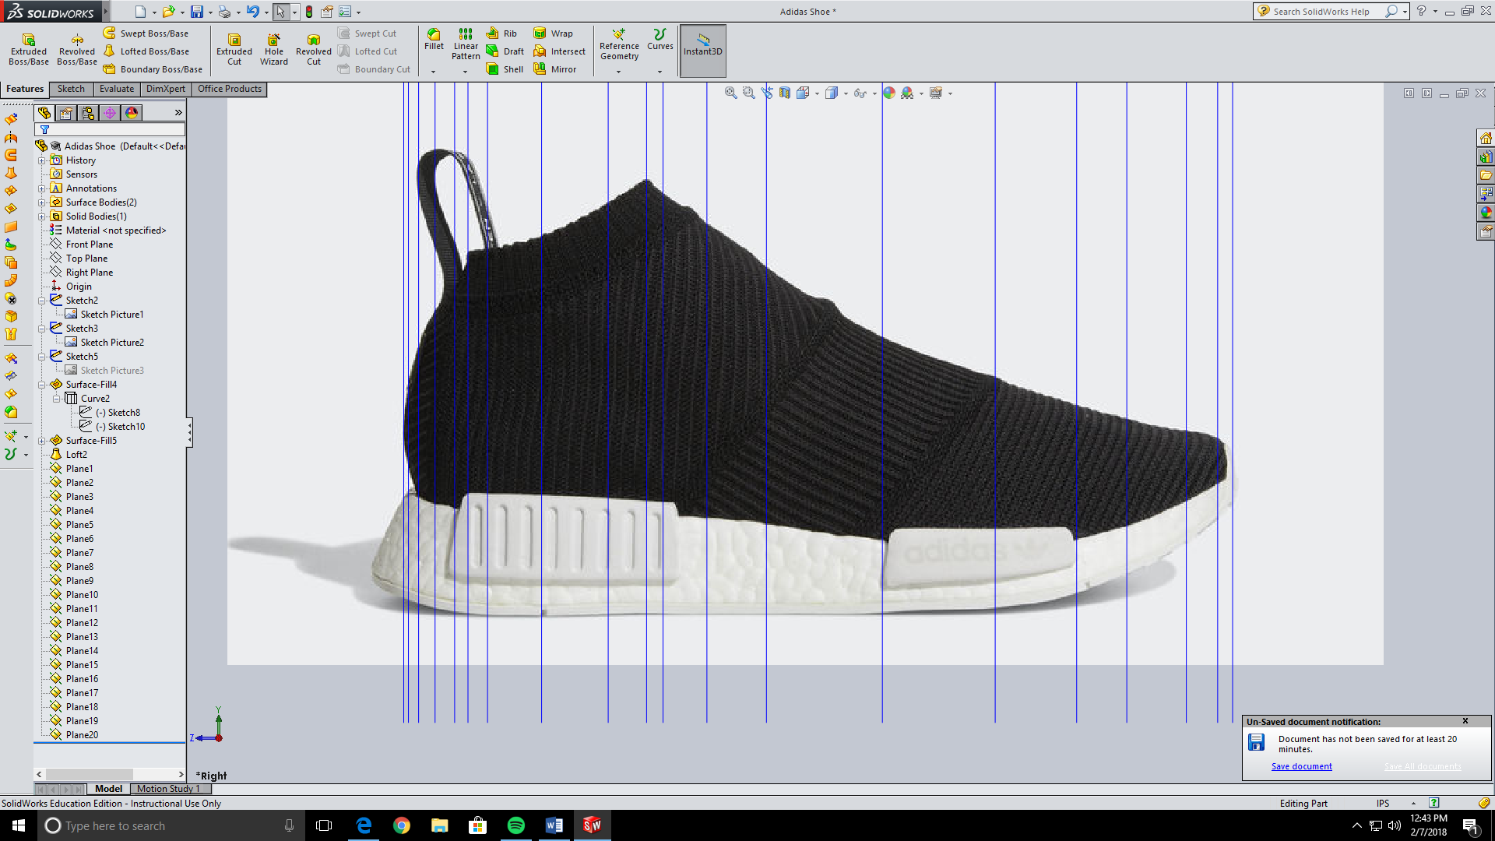

Before we sketch on these planes we need to make one more guide curve. Make a spline on the right plane that outlines the upper of the shoe. For the bottom of the upper just use the convert entities tool to copy the line you already made.

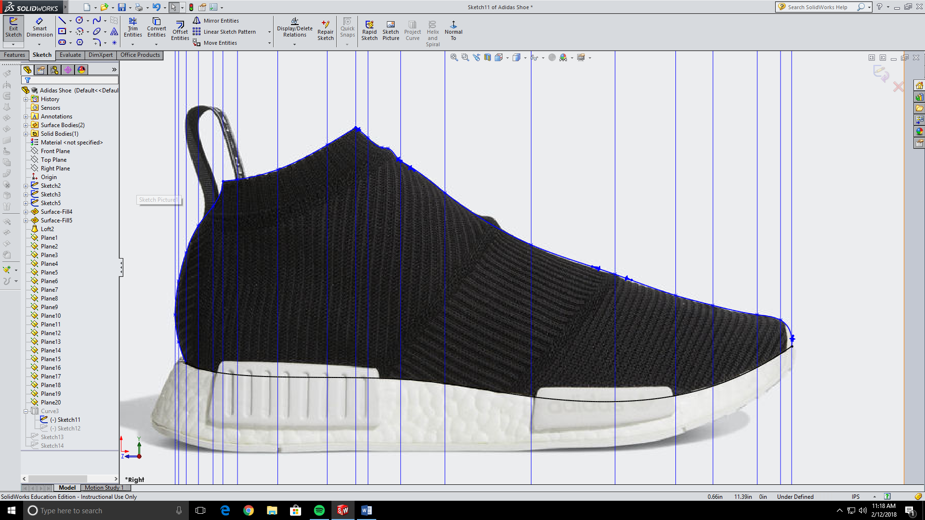

Go on the top plane and make a spline that follows the middle of the shoe and follows the curve of the shoe. Extend the line a little bit so that the project curve that we will make closes.

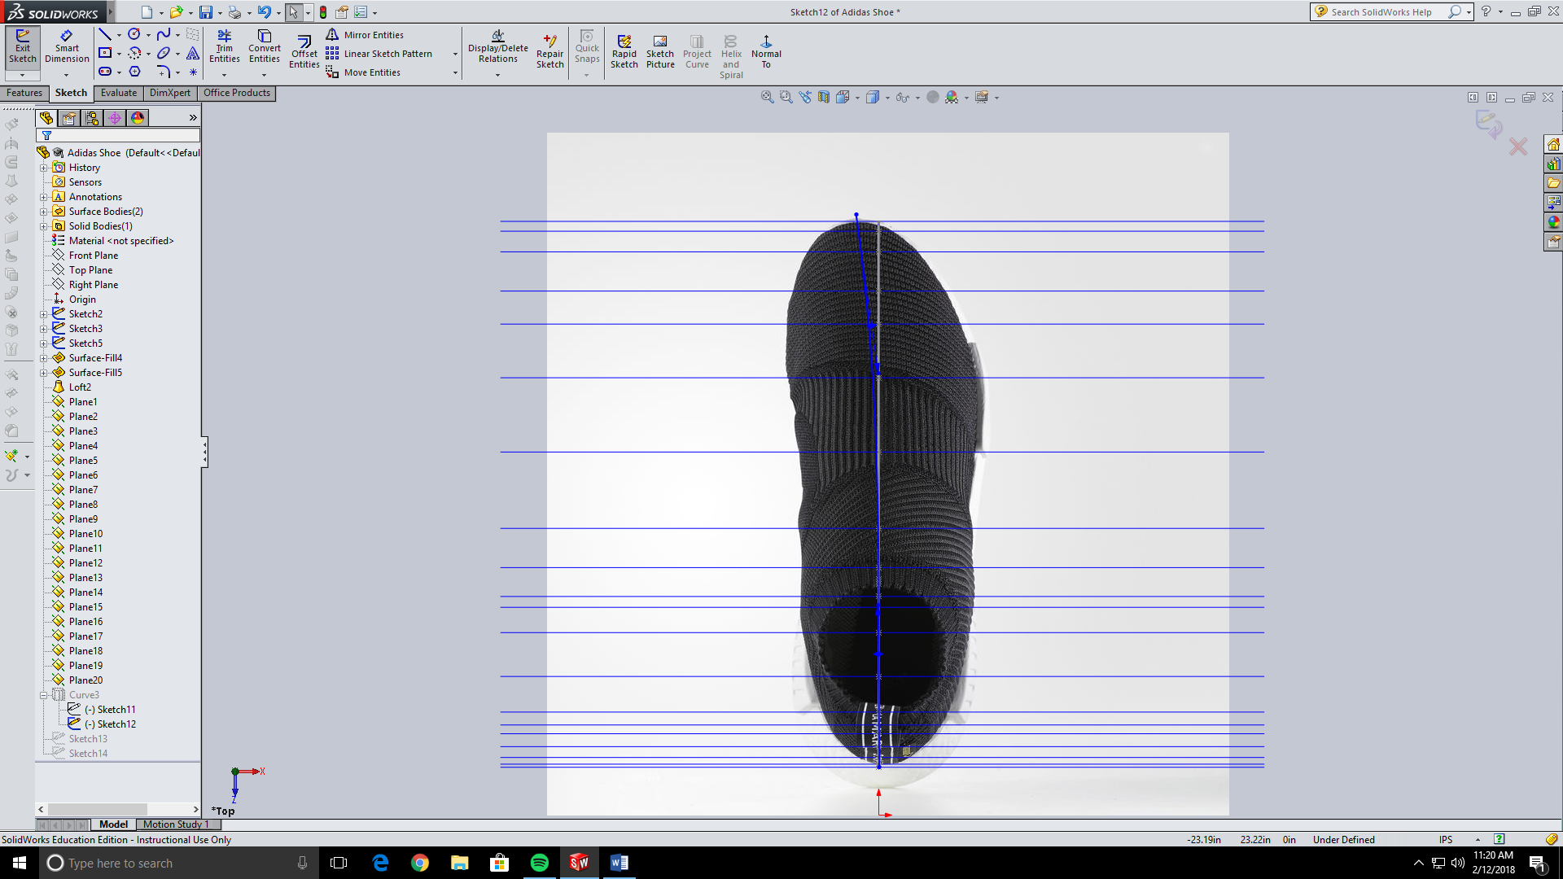

Then make a project curve from these two sketches. Make sure it is closed.

We will now start the process of making each cross-section on the planes we just made. First we need to make a starting point. Make a sketch and the farthest right plane, or the plane that is on the tip of your shoe. On the sketch put a point that pierces the project curve we just made that is on the right plane and the project curve that is the bottom of the upper.

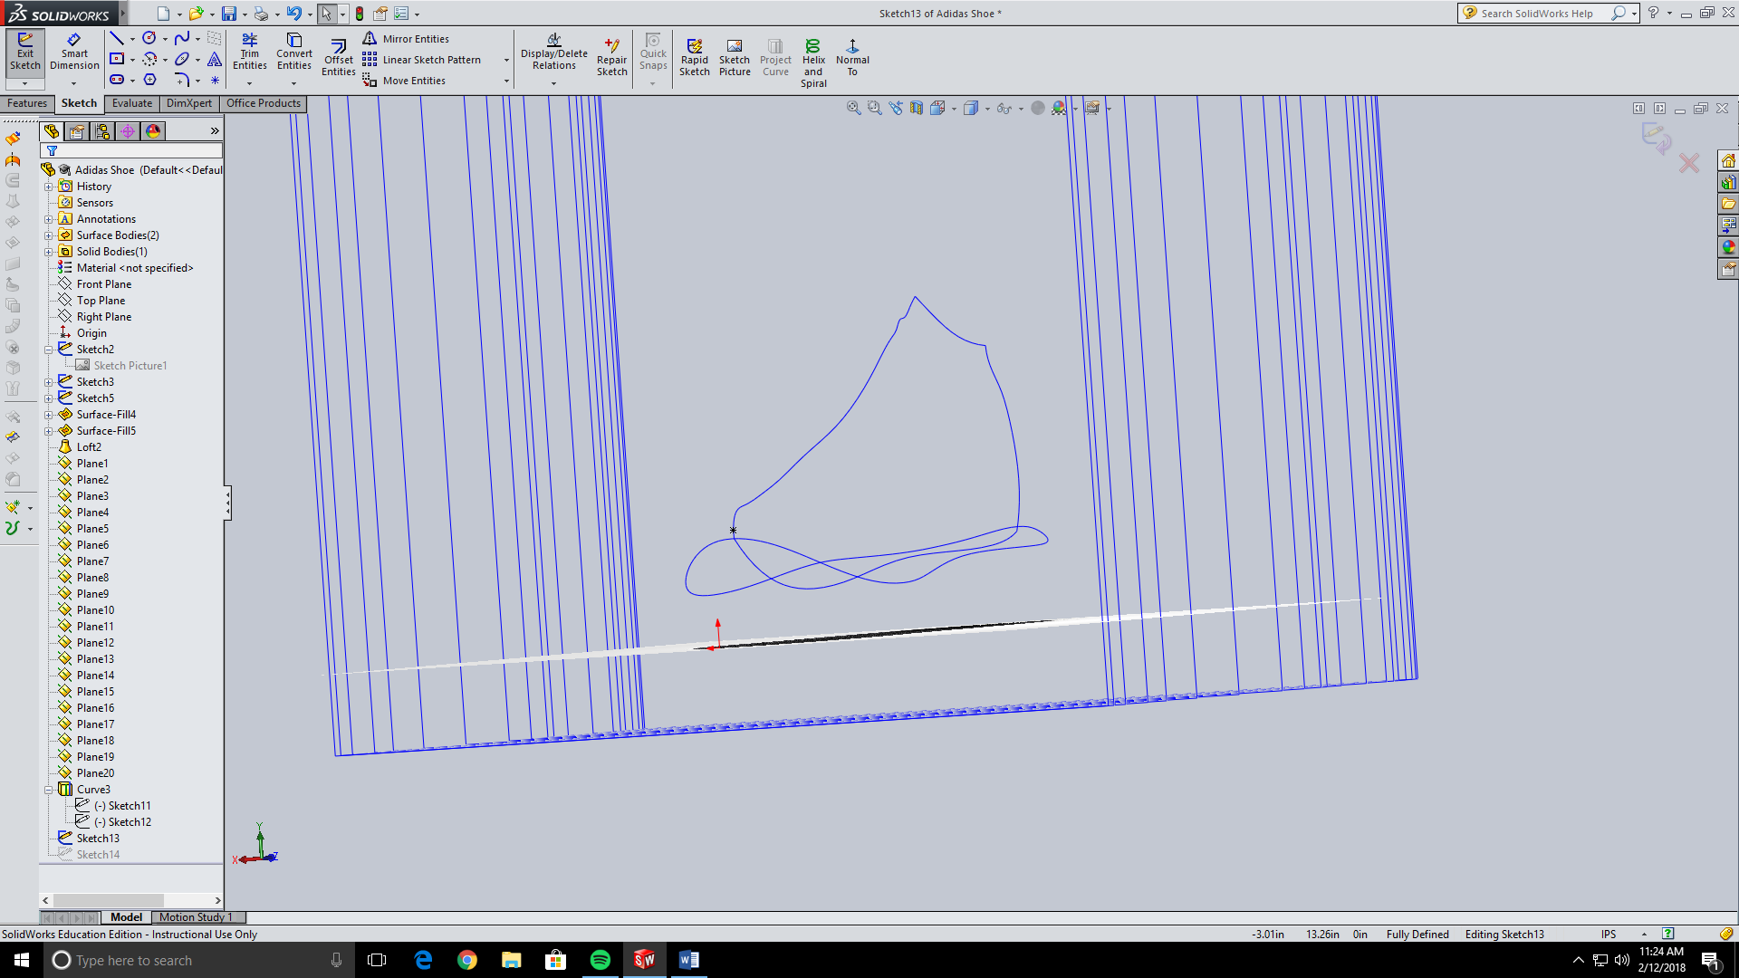

Now we need to make a sketch on the plane next to it. We are making a cross-section of the shoe so outline what the shoe would look like if you cut the shoe with a knife at that spot and looked at it from the front. I used two splines and pierced them to both project curves of the upper that we have made. Make sure the two splines are horizontal at the point where they meet so they are smooth and don’t create an edge. Make sure to also make a line at the bottom connecting the spline together.

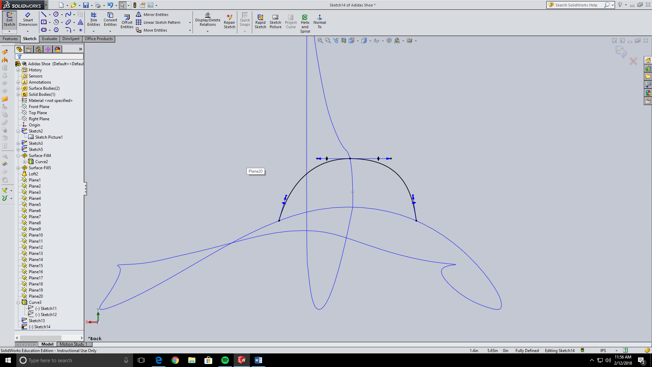

Now they rest of the upper is repeating this step and outlining the cross-section of each plane you made.

This is what mine looked like after a few cross-sections.

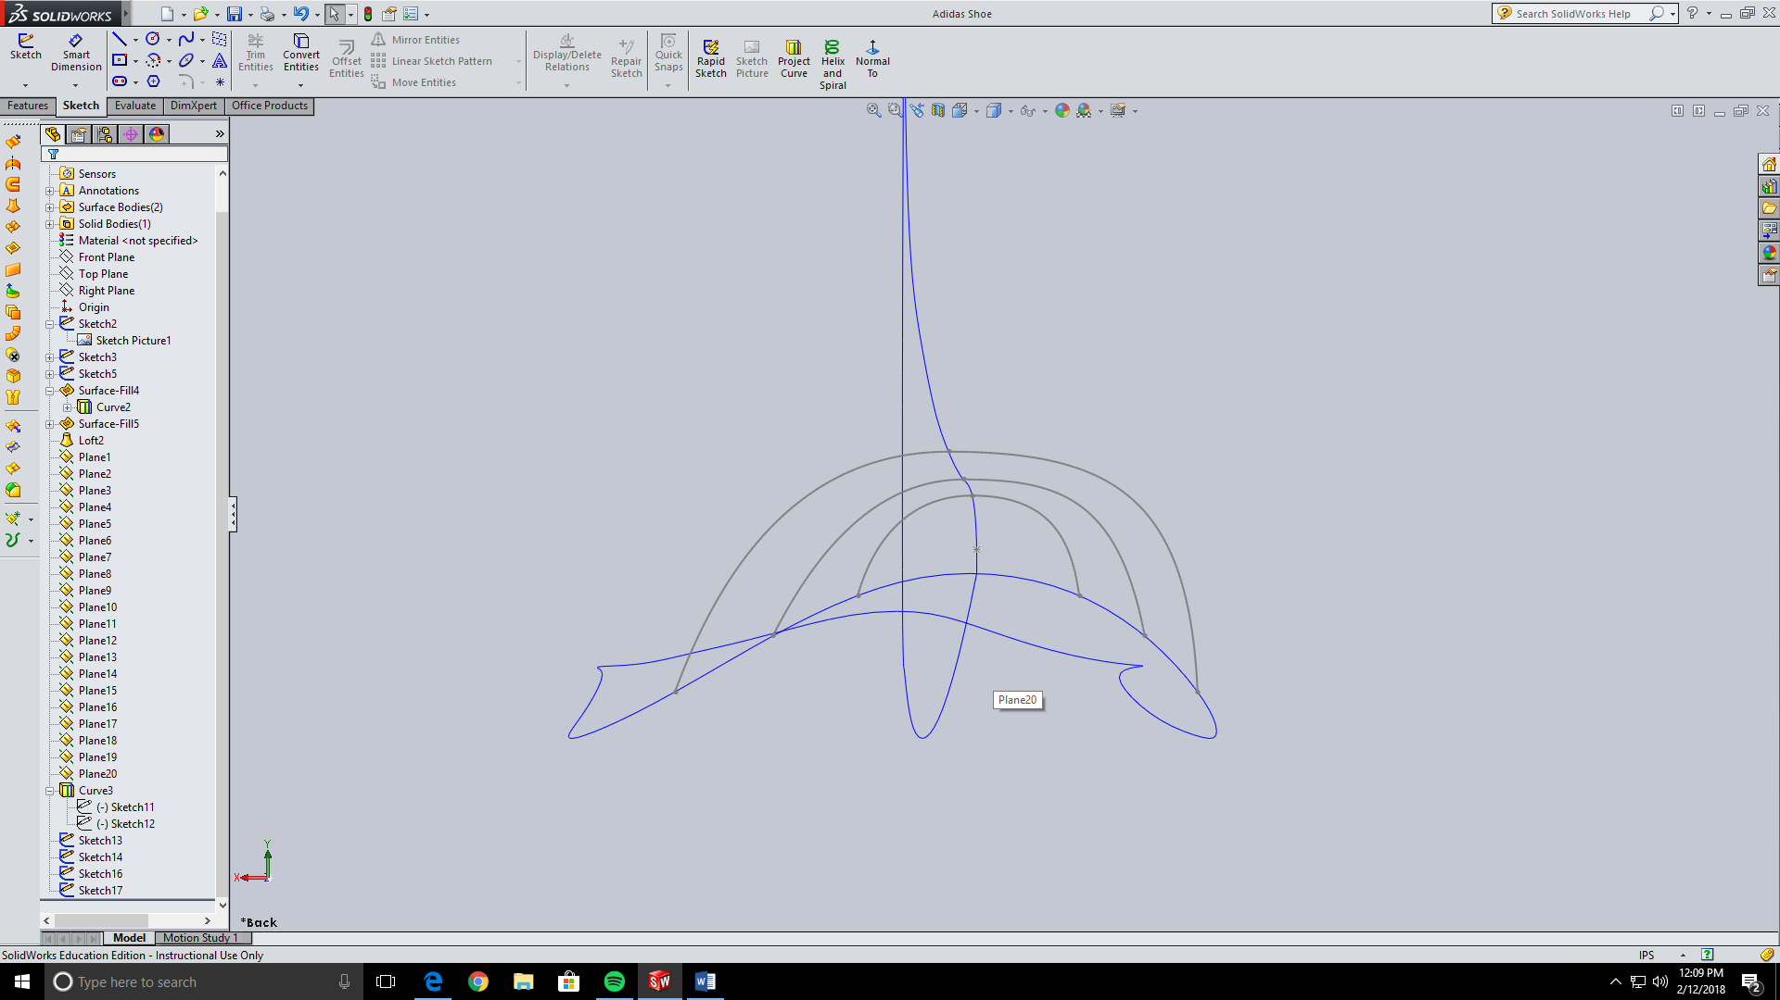

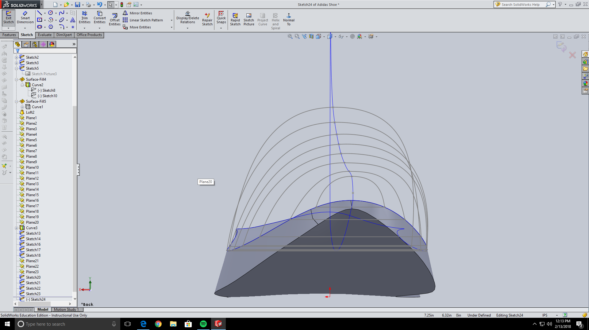

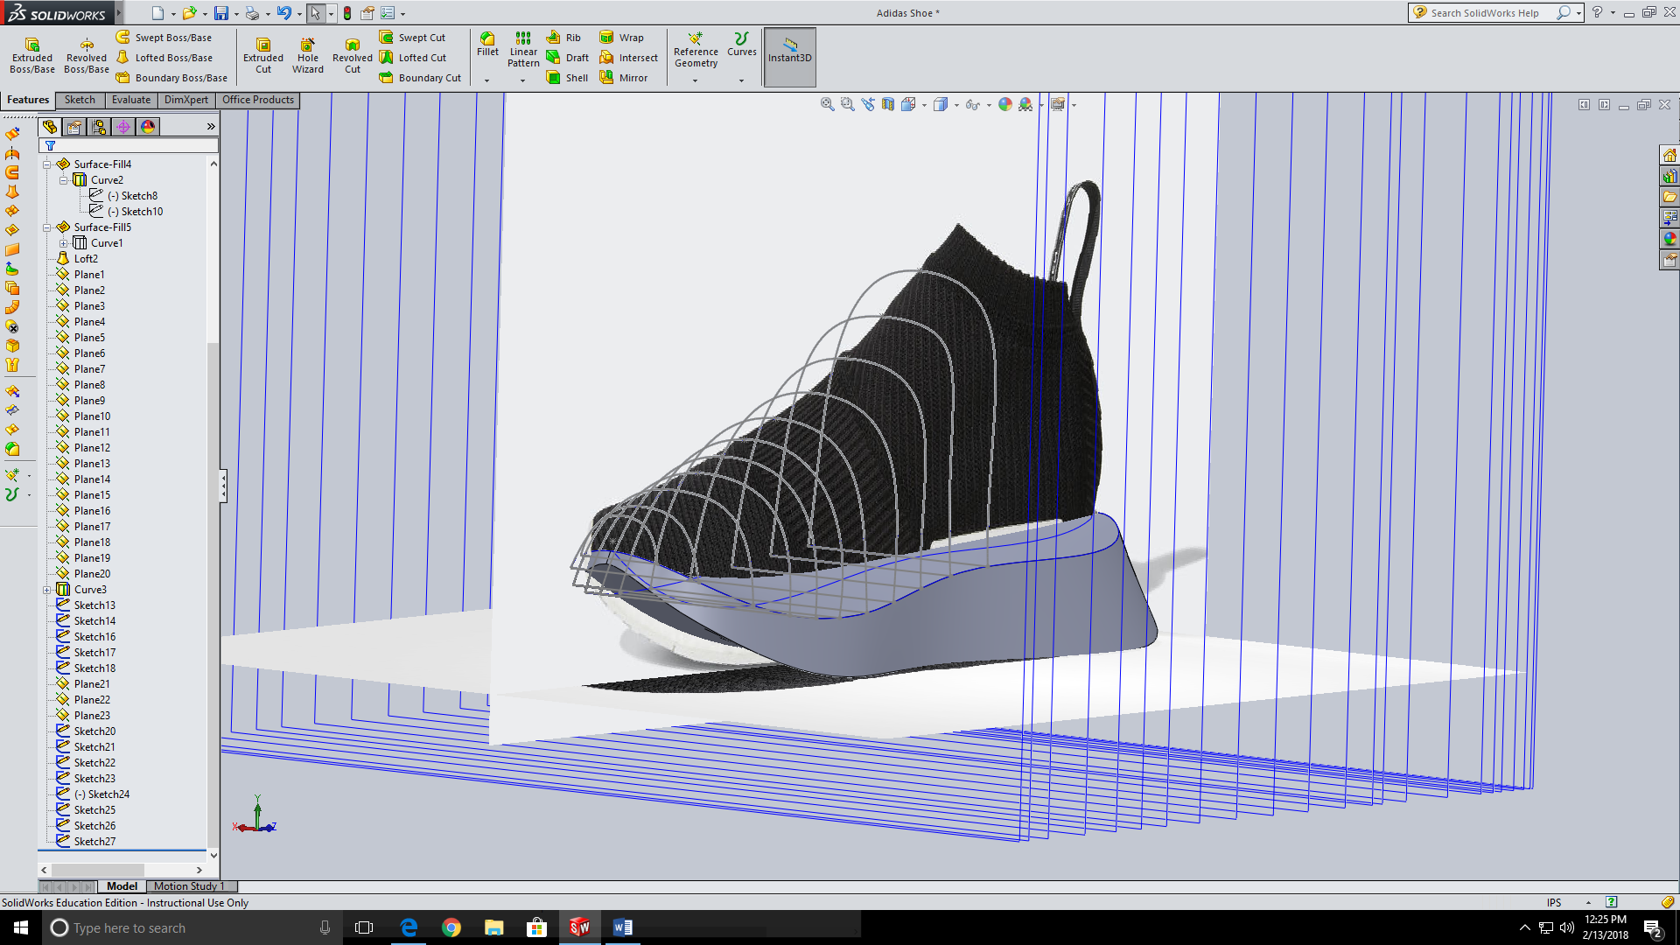

Once you come to a spot where you have a sharp edge like where my shoe has the hole opening for your foot, you will need to stop and loft all of your current sketches.

To do this go to the surface loft tool and select all of your cross-sections, including your first point. Then select any guide curve that will make your loft more accurate. The most important guide curve is the one that you pierced all of the cross-section sketches to. Note your solidworks may not be able to handle this big of a loft so I did it by selecting two cross-sections at a time then going back and editing the loft to add more each time.

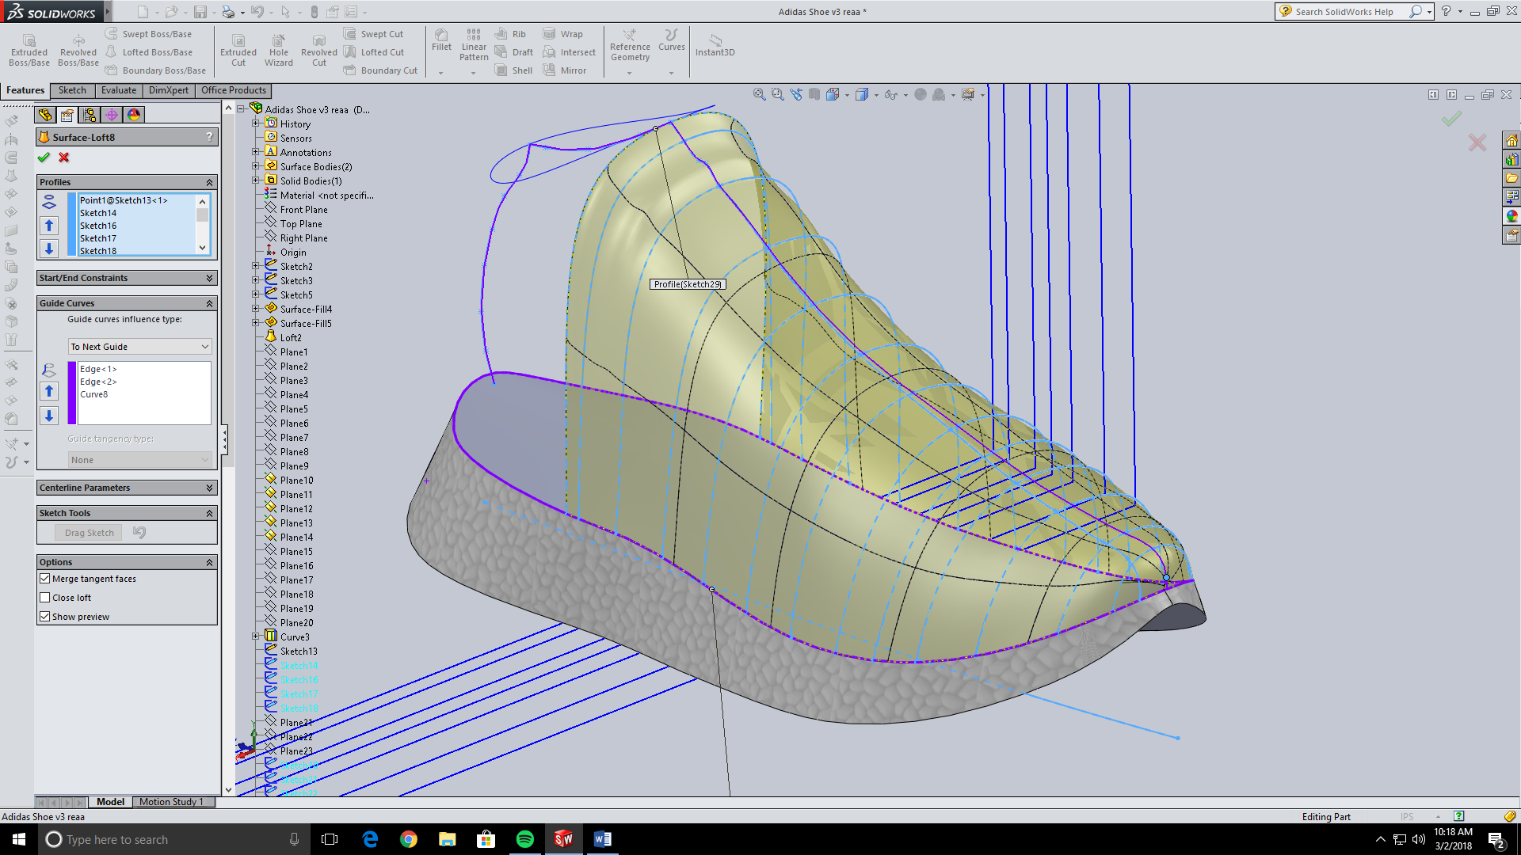

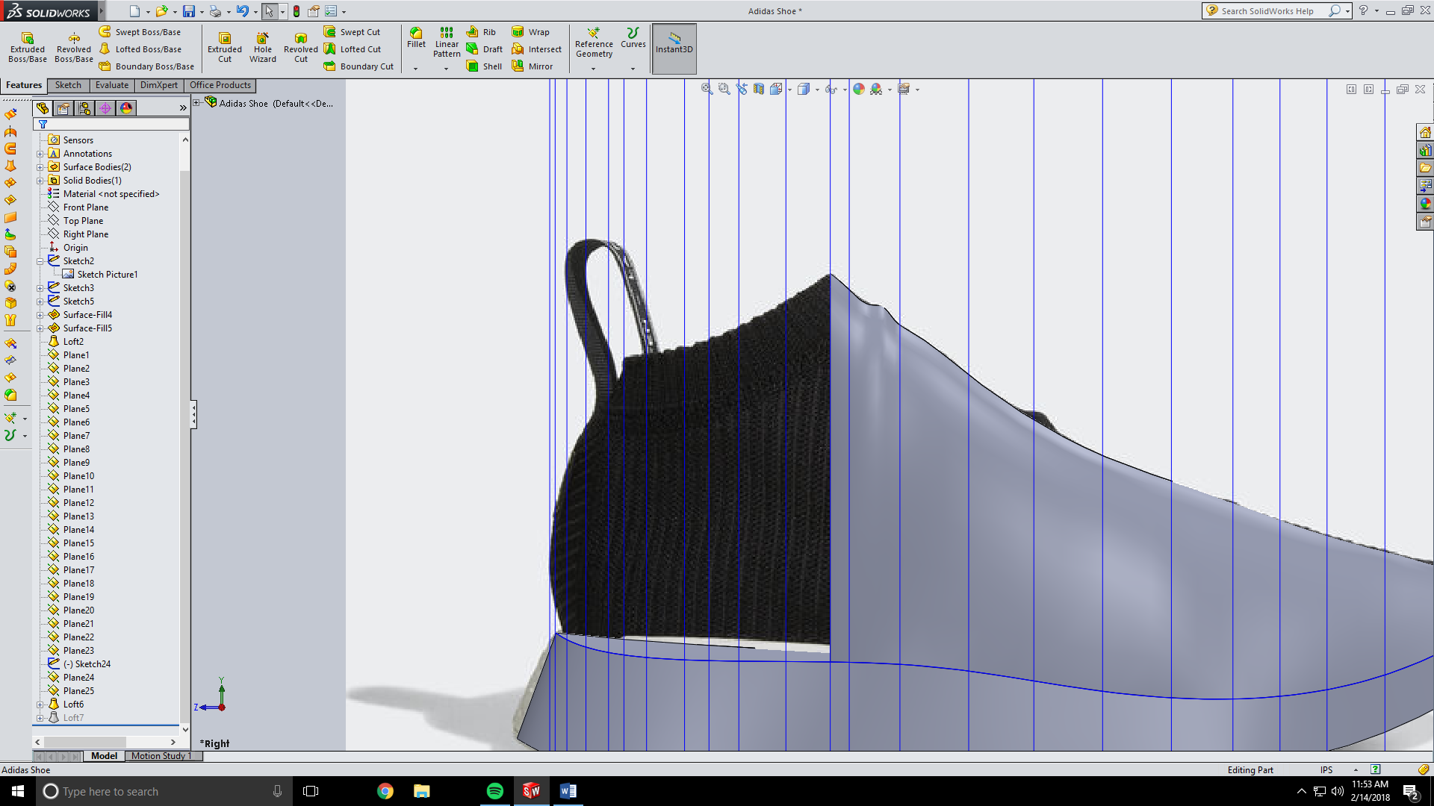

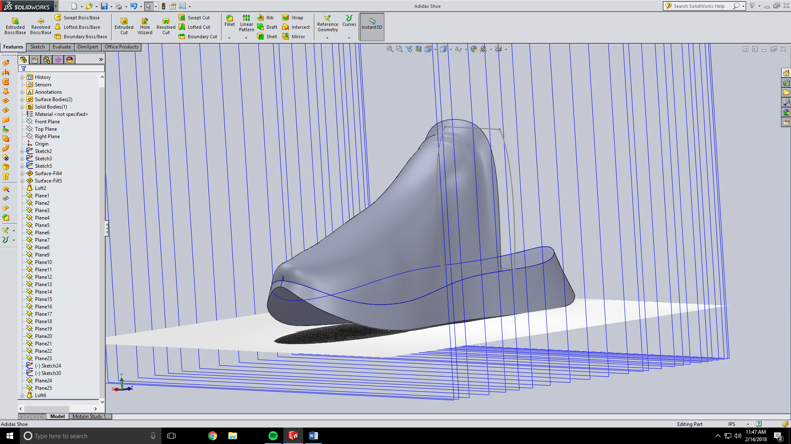

Before you all of the sketches for the foot opening we need to make another project curve for the next surface loft. Make a new plane that uses the two end points of your foot opening and the right plane. This should make a plane that is angled from the top plane.

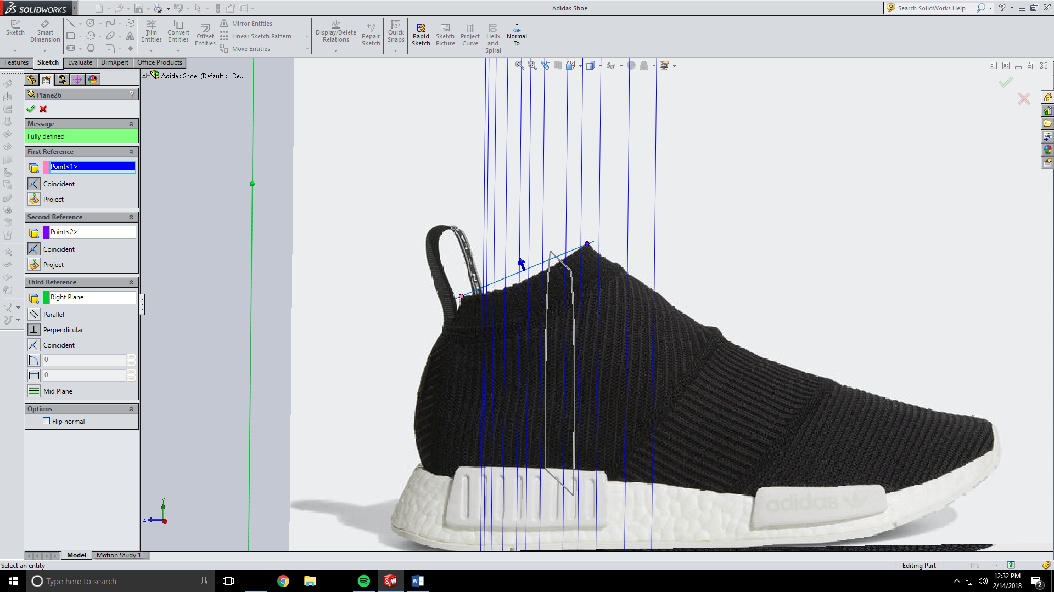

Now we need to make a sketch of the opening of the foot hole on this plane.

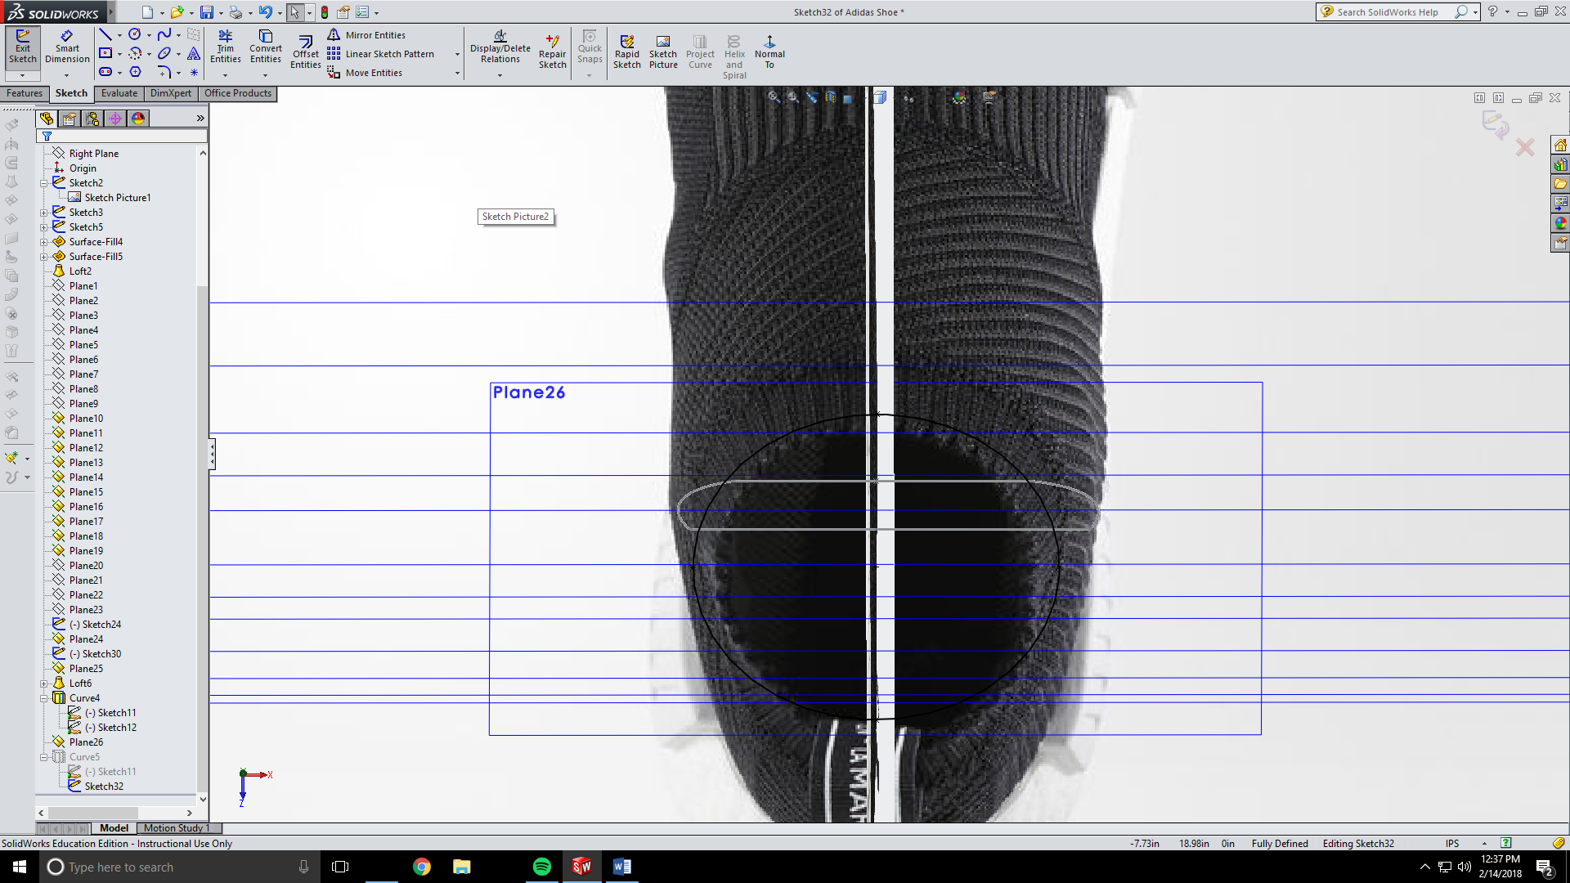

Now make a project curve from this sketch and the line on the right plane that outlined the shoe. This makes a dipped circle.

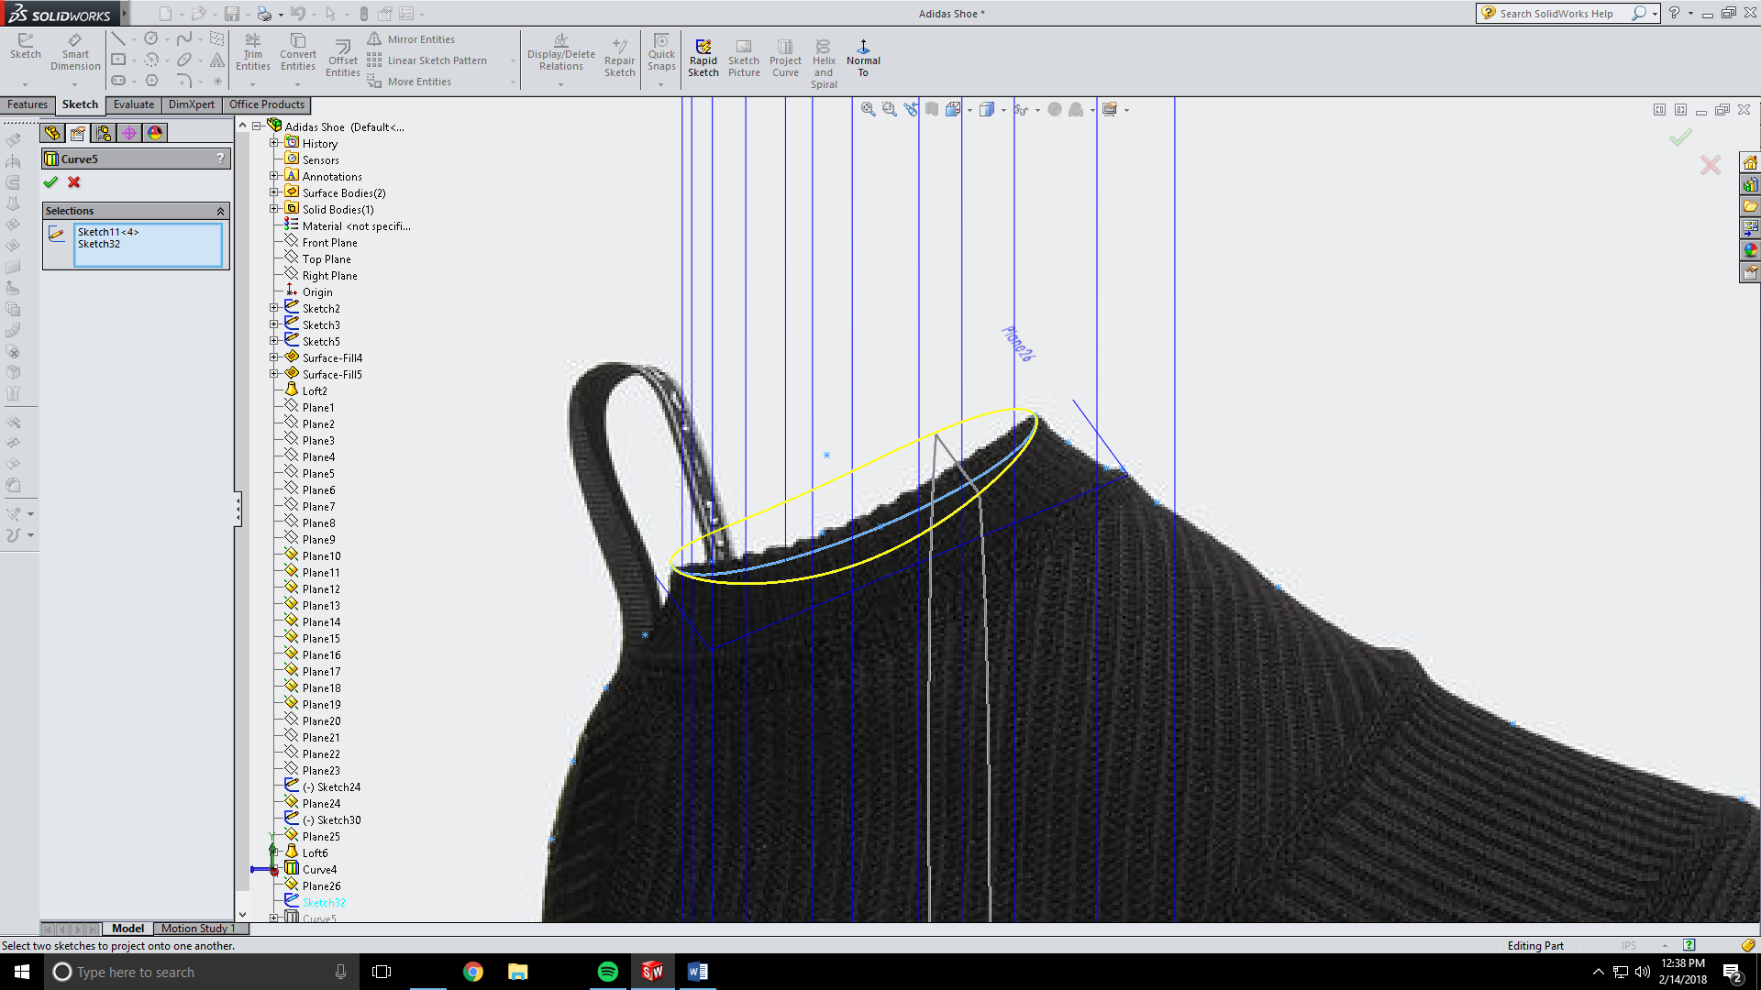

Now continue making your cross-sections but now pierce your sketches with the project curve you just made. Only make one side of the shoe and have it just be one spline.

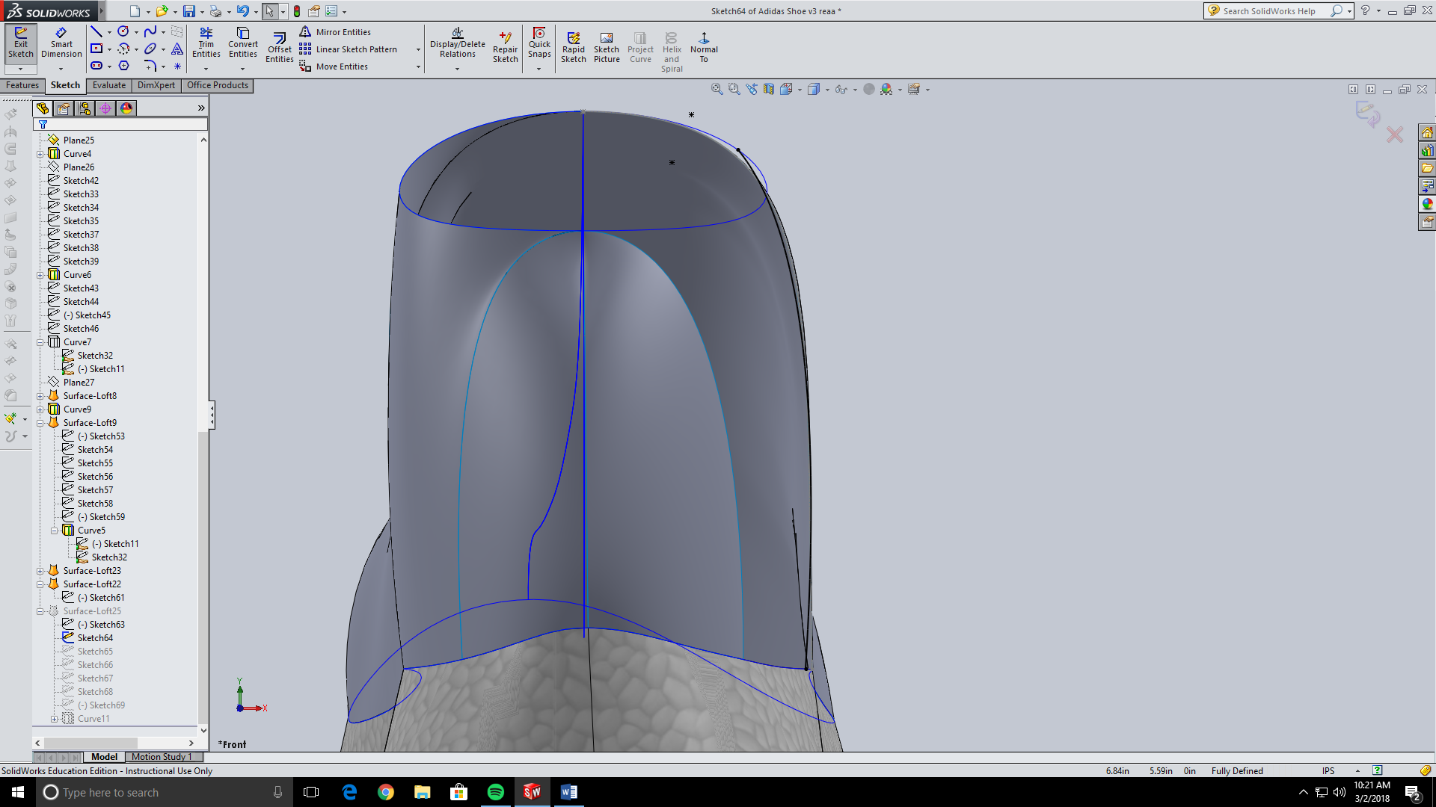

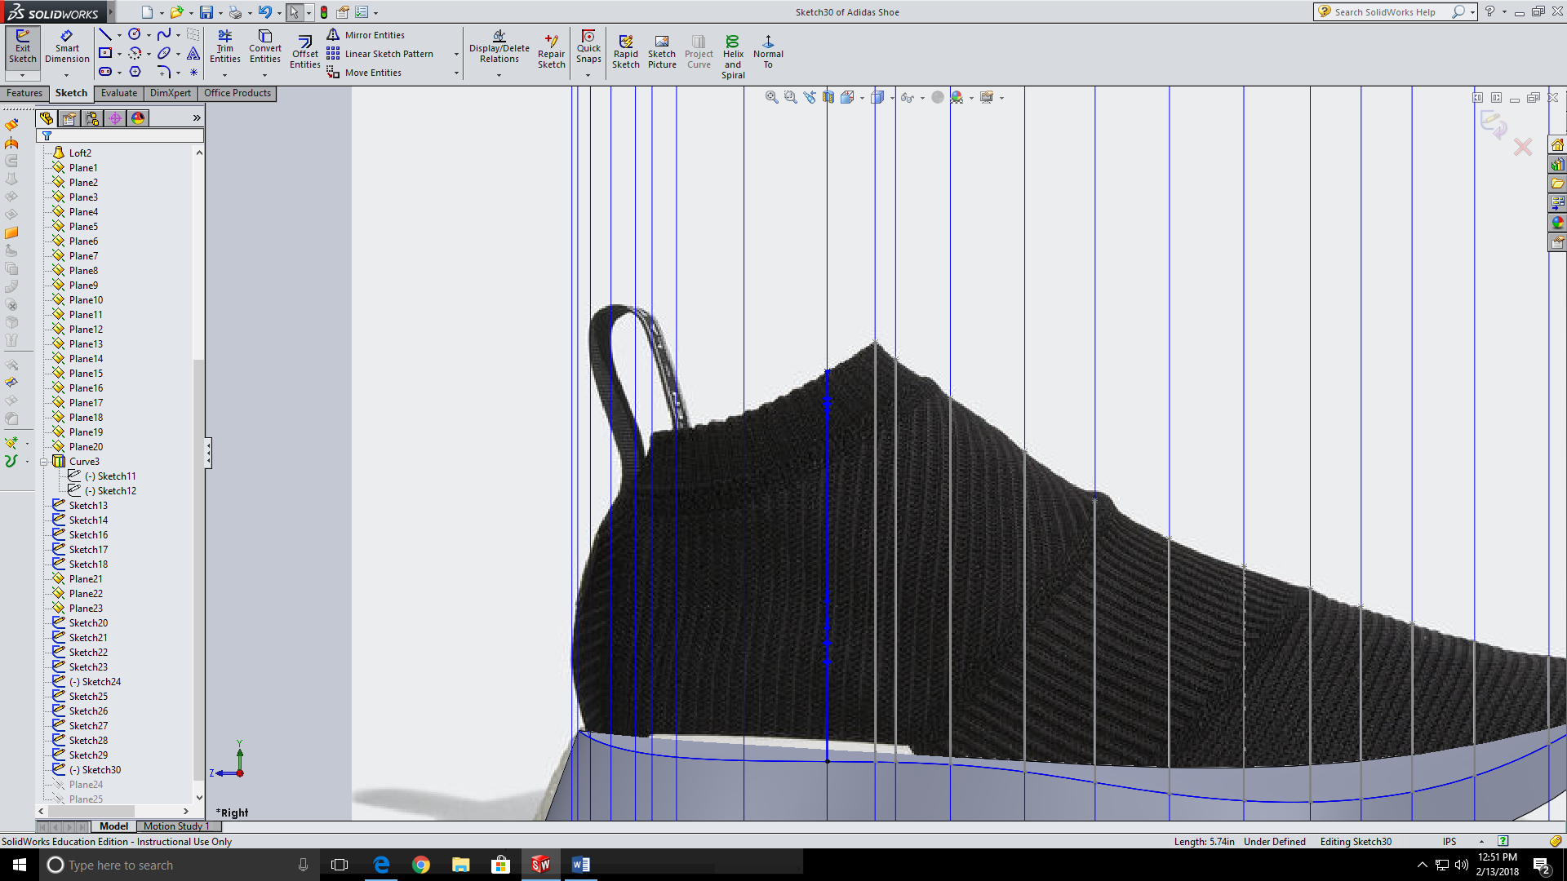

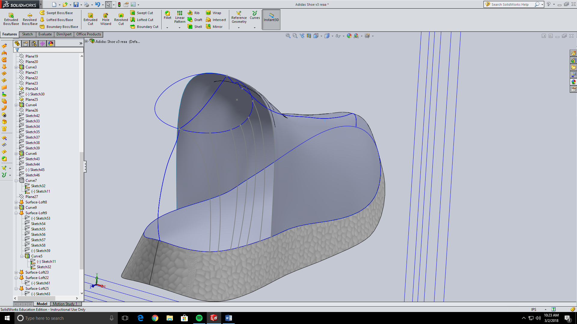

Now do the same thing to the other side. Note you will have to make a half curve for the start and end of the hole opening. I just used the convert entities tool on the curves the made a hidden line that pierced the center guide curve then trimmed the half I didn’t need.

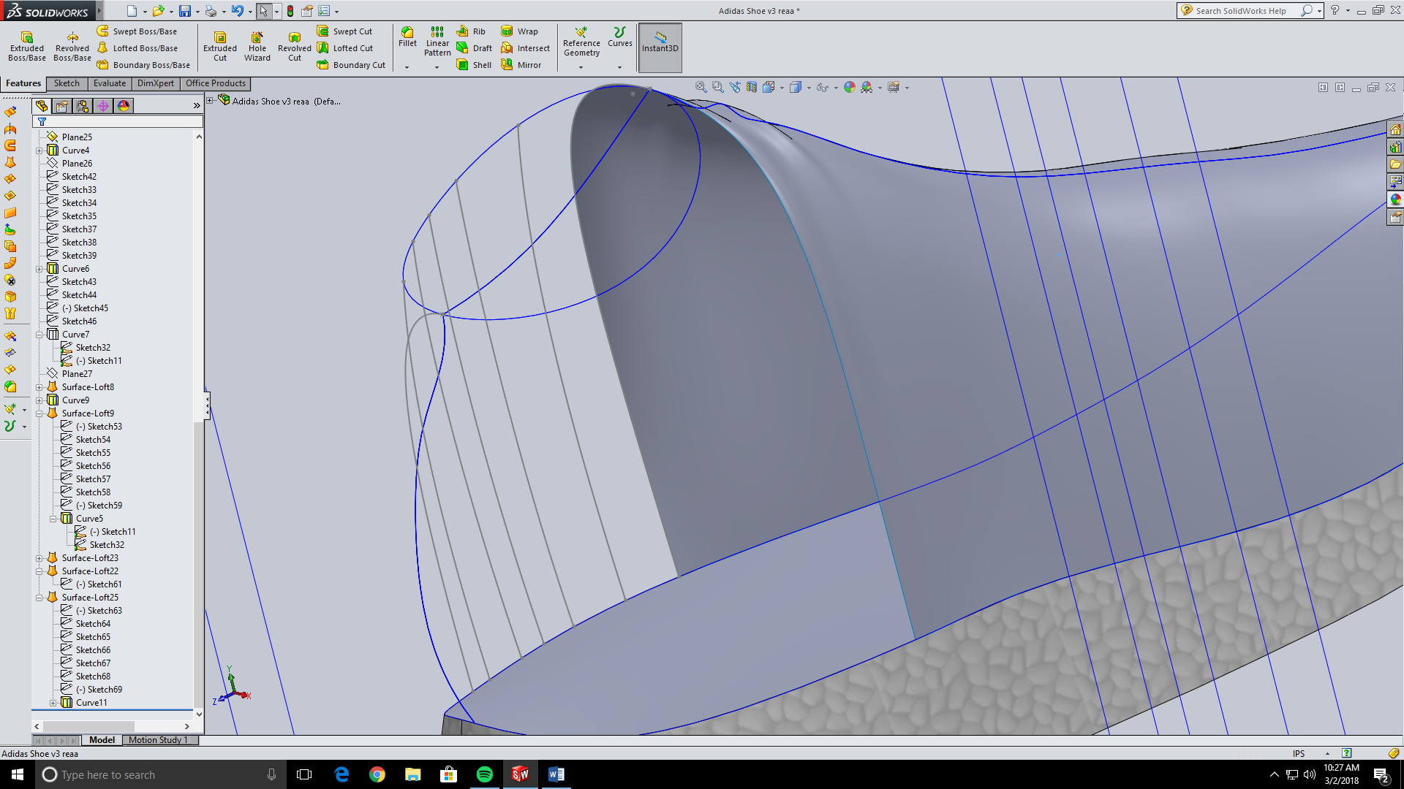

Now make two surface lofts for both sides of the shoe. Use the guide curve we just made along with the previous ones that still apply to this loft.

Should look smooth and flush with the previous loft.

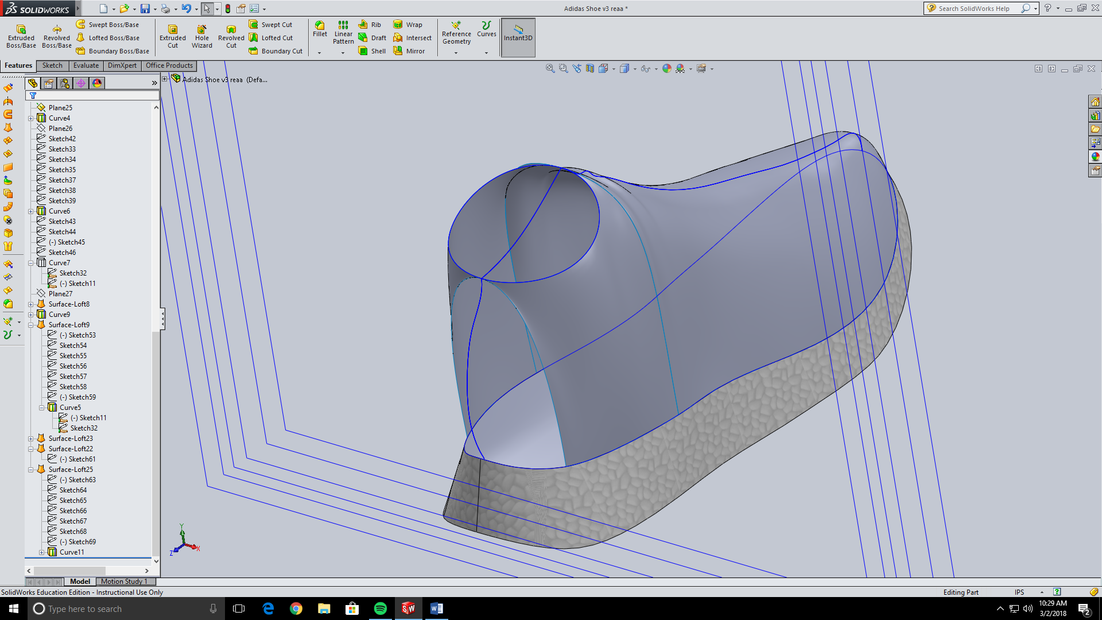

Now we need to make the heel. We are going to change up which direction we loft this time. We need to have a start sketch and a finish sketch. You have already made the end sketch without knowing it. For this use the guide curve that outlines the heel on the right plane. For the starting sketch convert entities of the ending edges of the two previous lofts. Note we will be making two lofts so create two starting sketches.

Choose the two sketches and use the bottom outline as a guide curve.

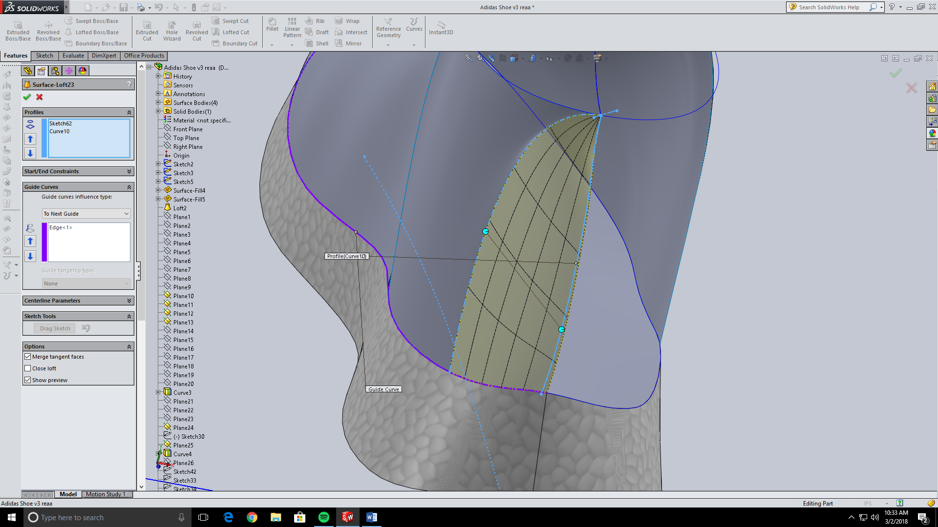

For the other side make your end sketch the edge of the surface loft you just made.

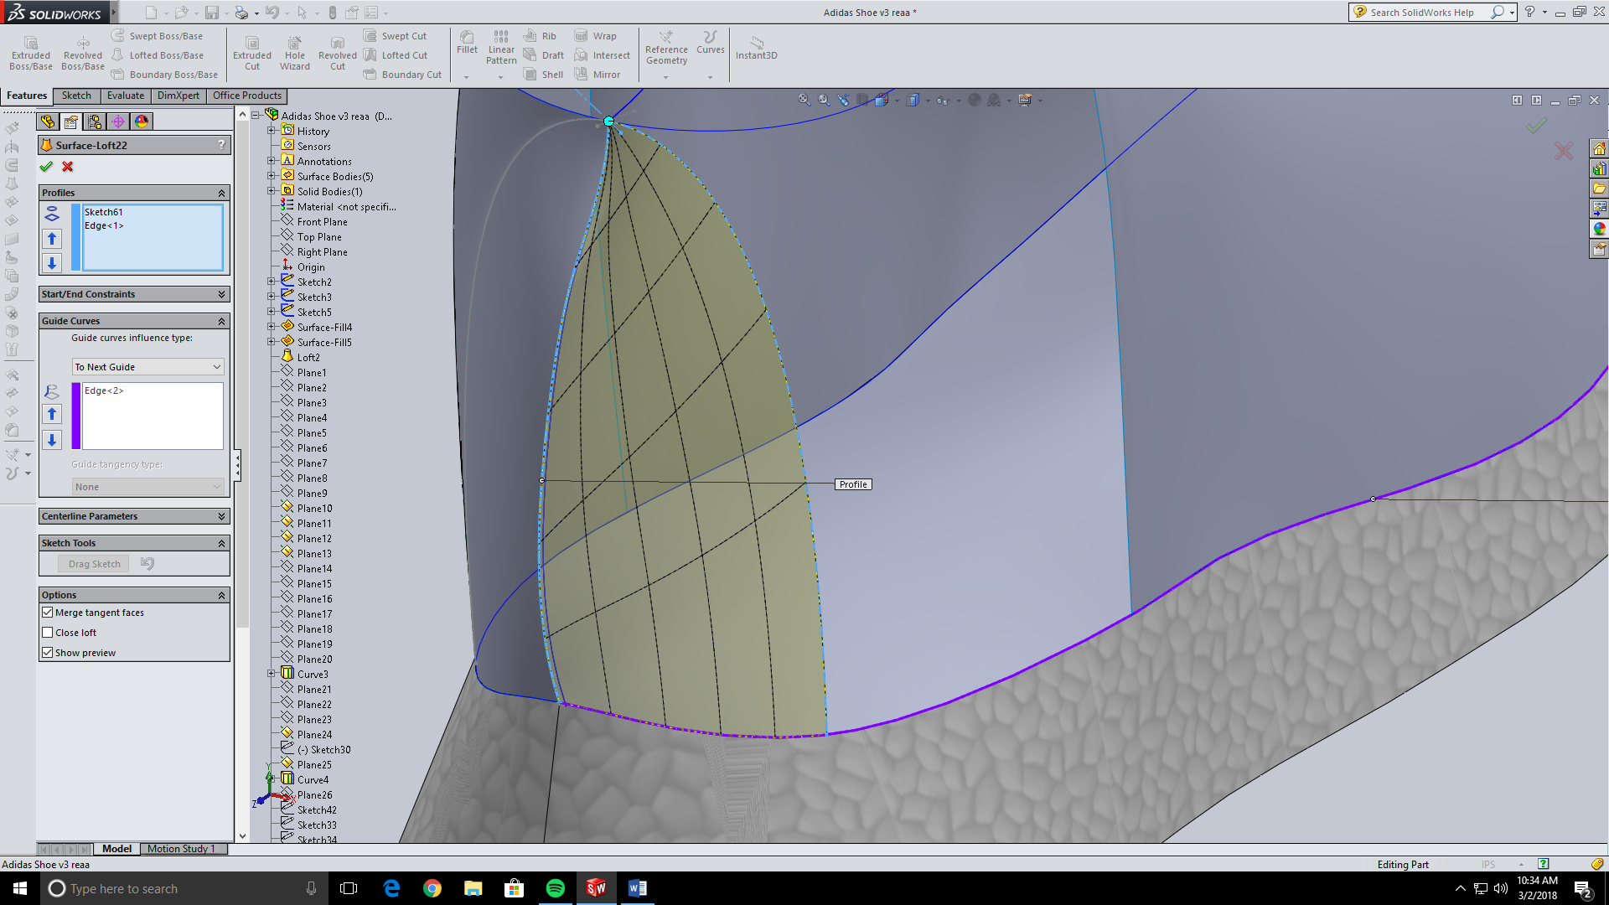

Now here is what your almost finished project looks like.

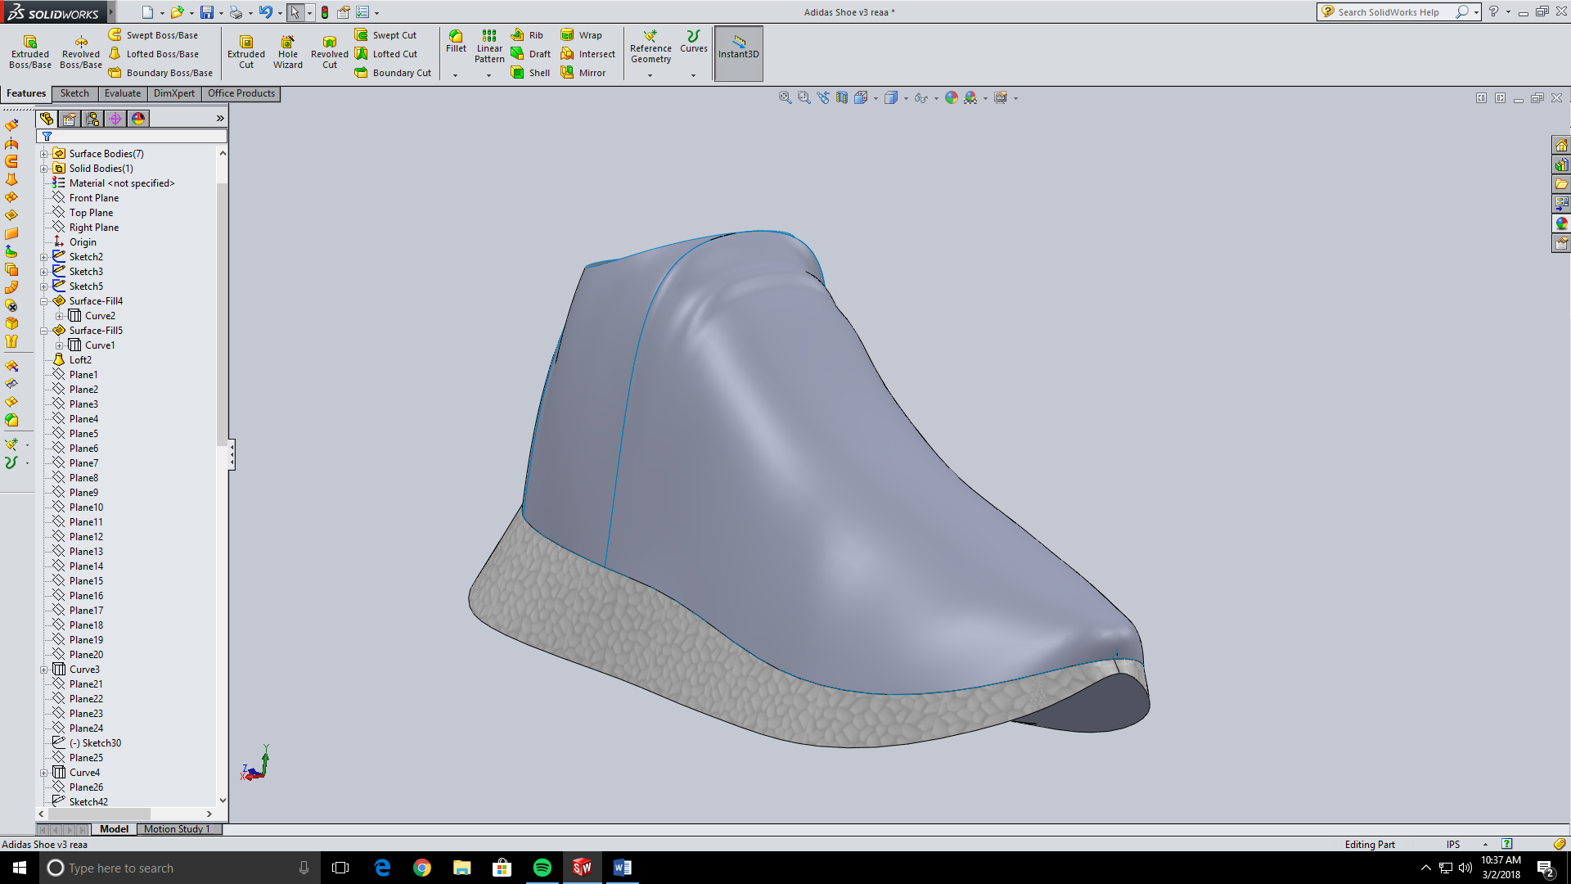

From here on out the tutorial will follow steps specific to this shoe only, like the three “bumpers” on the side, and the finger loop on top. However, if you need help on appearances, mirroring parts, lofted cuts, or offset extrudes then stick around.

Next we will make the three bumpers on the sole of the shoe. Make a sketch on the right plane and outline the back bumper from the sketch picture we imported at the start. There is two ways to extrude this. One is way easier and more accurate but solid works didn’t allow me to use the tool. This is the offset extrude from surface. The other way is a simple extrude and then using the loft cut tool. If offsetting works for you then click on the boss extrude tool and go to offset from surface. Select the sole and enter in the dimension that suits your needs. This will create an extrusion that replicates the curve of the sole.

Since this technique didn’t work for me, so I just extruded the prism and then used the loft cut tool. To use this, make two sketches on both ends of the bumper that looks like what you wish to cut off of the bumper. Then makes two guide curves one on top, and one on the bottom. These need to follow the curve of the sole.

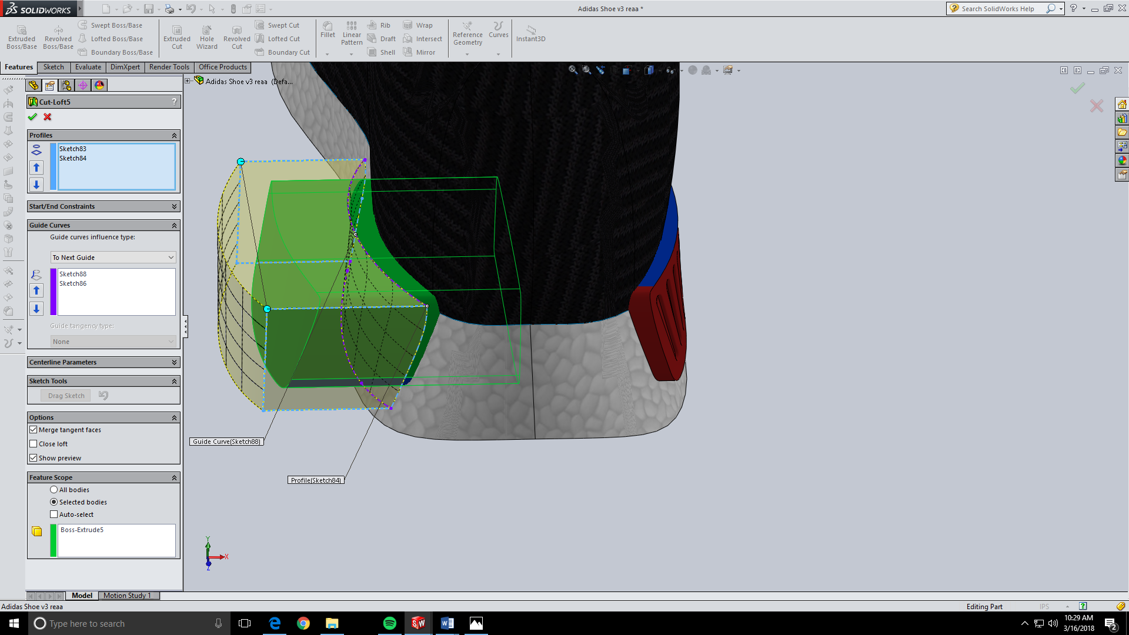

Next we need to make the vents in the bumper. Again go to the right plane and use the slot tool to make each vent. Then cut extrude through all. After that go to the extrude tool and use the offset from surface tool. Use the outer surface of the bumper and make the distance around 0.1 in.

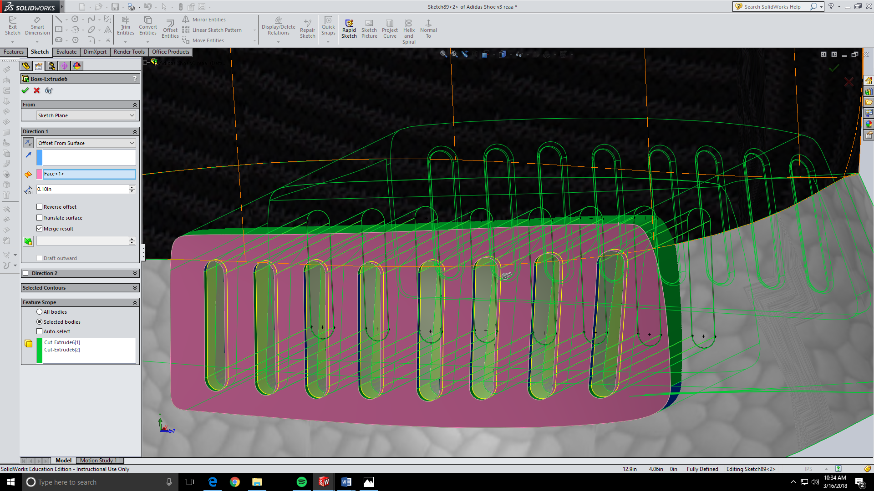

Now filet the vents and the two back bumpers are complete.

The front bumper uses the same techniques just without the vents. I added the Adidas logo and word on the surface using the extrude offset from surface tool.

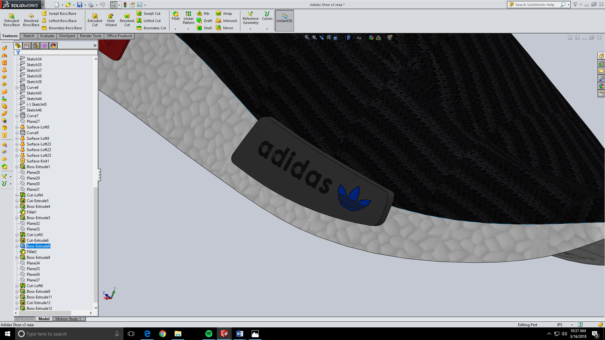

The finger loop is a simple spline on the right plane extruded to make a thin loop.

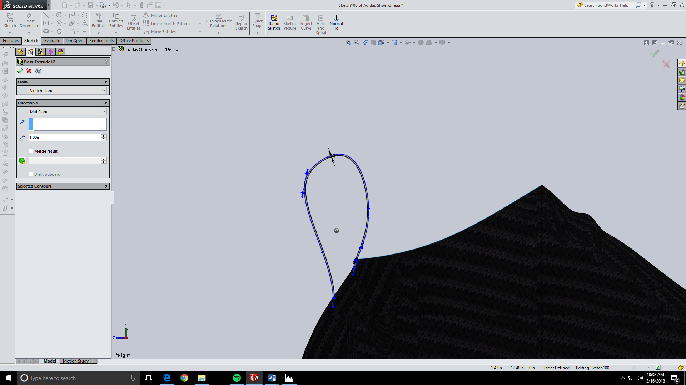

Now all modeling is done for this shoe and the rest of the project is appearances and mirroring the part. I found a picture on the internet of just the Adidas boost. I used this on the sole and it worked perfectly. The bottom of the shoe is the picture we imported near the beginning and that also fit perfectly. Other than that I used a few more internet pictures and simple colors to make the shoe look complete and accurate.

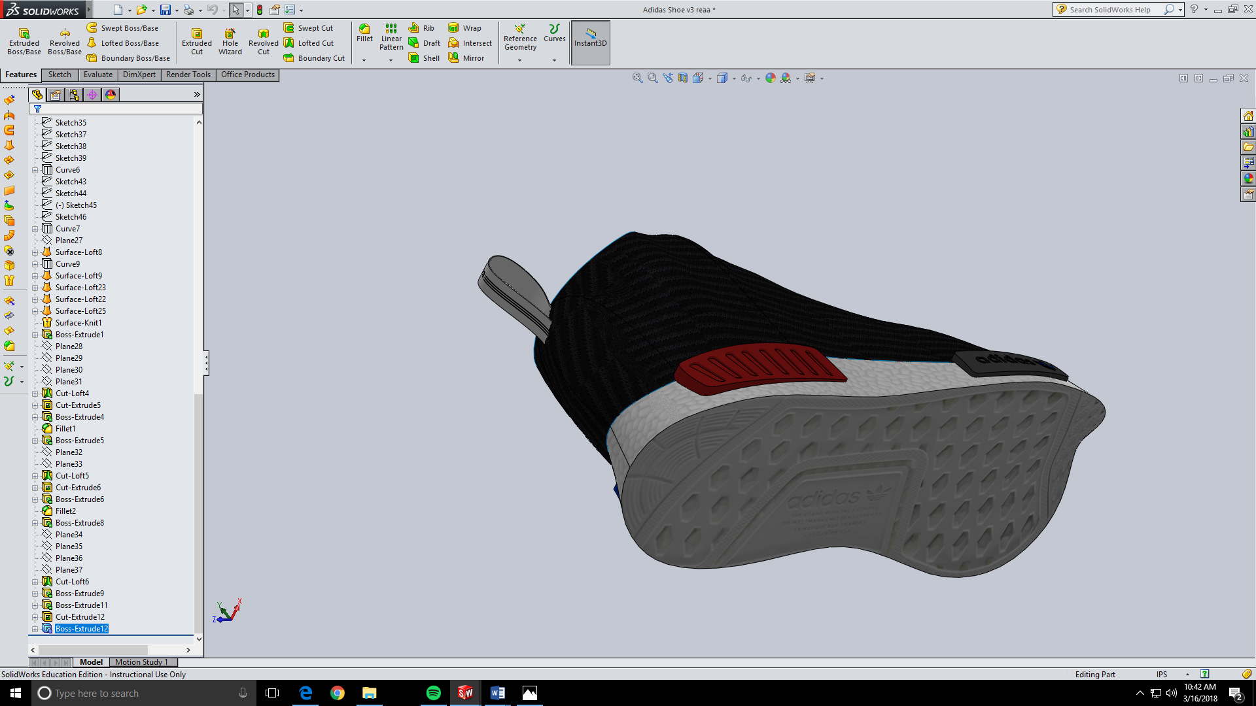

The last thing to do is to mirror the part. To do this use the mirror part tool found under the insert tab. Make sure u have a flat surface selected before you mirror. After that you are done and can assemble the shoe however you want!

